Caterpillar Emissions Tracker: A Database for Sustainable Energy Transition

# Database Design Document

Version 1.0

04/20/2025

Table of Contents

1 Introduction 3

2 Solution Review 8

3 Business Rules/Assumptions/Constraints/Risks 10

Business Rules 10

Assumptions 11

Constraints 12

Risks 12

4 Database Design 14

Entities and Attributes 14

Entity Relationship Diagram 27

Relational Schema 27

5. Implementation 37

5.1 Create and Update Tables 37

5.2 Reports 40

6. Database Administration and Monitoring 43

6.2 Security and Privacy 44

6.3 Backup and Recovery 46

Appendix A: SQL and Reports 46

References 83

## Introduction

Caterpillar is a company that focuses on producing tractors, earth-moving equipment, and loaders. Caterpillar (CAT), which started producing for European customers in the early 1900s, is now at the top of the global heavy machinery industry. In 1931, CAT began producing the first Caterpillar Diesel Sixty Tractor. This was a significant milestone because the diesel engines were a breakthrough in terms of power and efficiency compared to gasoline engines. This was only the start of Caterpillar and their historical innovation. Another important milestone for CAT was in 1969, when the Caterpillar generators helped power the Apollo 11 mission to the moon (Caterpillar, n.d.-a).

Caterpillar defines what they stand for and what they believe in on their Code of Conduct, “the code”. In this document, they highlight their business practices are guided by their core values: integrity, excellence, teamwork, commitment, and sustainability. They also state the ethical standards and behaviors expected from employees. Caterpillar aims to reduce environmental impact and promote sustainable practices in manufacturing and operations.

Although CAT started producing for European customers, they now operate in over 190 countries, serving different industries like construction, mining, and energy. CAT owns a central warehouse located in Belgium that meets the services and needs of its European customers. CAT must be able to respond to customer requests for spare parts. There are 23 distribution centers in 11 countries. CAT created a 48-hour response guarantee that involves free delivery if the spare part does not arrive within 48 hours. This shows the commitment that Caterpillar has devoted to their customer service.

Through the constant innovation and global presence of Caterpillar, they have secured their position as a global leader in the heavy machine industry. With the dedication that Caterpillar shows to its core values and customer service, it will continue to thrive and make a positive impact.

**Caterpillar’s Strategic Goals and How They Inspired Our Project**

Caterpillar Inc. functions as the worldwide leader that produces tractors together with earth-moving equipment and loaders in addition to industrial machinery products. The company focuses on three strategic priorities of customer satisfaction, operational excellence, and sustainability by implementing data-based solutions and digital transformation to boost network efficiency (Caterpillar, n.d.-b).

As stated in Caterpillar’s strategic mission:

"*Our company strategy reflects our legacy and our continuing commitment to meet the needs of our customers and the communities in which we live and work. United by our Values, Caterpillar employees around the world share a focused view of our business through the Operating & Execution Model, through which we are making strategic choices today to create profitable growth for tomorrow. Together, with our partners, we are providing the solutions that help our customers build a better, more sustainable world"* (Caterpillar, n.d.-b).

To achieve this vision, Caterpillar focuses on four key strategic areas (Caterpillar, n.d.-c):

* Services: Augmenting the services to increase customer support, aftermarket support and equipment lifecycle management.
* Expanded Offerings: Creating new products, digital products and financial services to cater to divergent needs of the market.
* Sustainability: Committing to environmentally responsible operations and sustainable product solutions.
* Operational Excellence: Improve efficiency throughout manufacturing, logistics and supply chain management.

The enterprise strategy at Caterpillar enables profitable expansion through strategic investments intended for developing high-value areas while prioritizing sustainable operations and emission adherence. As a leadership framework the Operating & Execution Model enables organizations to track business region performance by confirming essential investments fulfill strategic company objectives. (Caterpillar, n.d.-b).

On the other hand, Caterpillar implements sustainability throughout its company growth by creating innovative emission reduction solutions. The company meets strict global standards including EU Stage V and U.S. EPA Tier 4 Final regulations through which it achieves an impressive 96% reduction in NOx and PM emissions since the time of initial requirements (Caterpillar, n.d.-d). The company advances its performance capabilities through its implementations of Diesel Particulate Filters and telematic systems for meeting environmental objectives. The company strengthens its commitment to clean sustainable solutions by making persistent modifications to follow updated emissions requirements which results in improved operational effectiveness.

**SWOT Analysis**

As a worldwide manufacturing authority for construction and mining equipment Caterpillar Inc. strongly impacts the environmental outlook of its industry. The SWOT analysis of environmental sustainability at Caterpillar offers essential information for creating the “**Caterpillar Emissions Tracker: A Database for Sustainable Energy Transition**” project.

**Strengths**

* Commitment to sustainability: the sustainability principles at Caterpillar became core organizational values that focus on decreasing highway pollution through the advancement of green technologies. The company continues its motivation to environmental stewardship and innovation through its 2030 sustainability goals(Caterpillar, n.d.-d).
* Technological innovation: The company maintains its innovation focus by working with industry leaders including BHP for testing the Cat Dynamic Energy Transfer (DET) system that combines operational effectiveness and emission reduction benefits(Reuters, 2024).

**Weaknesses**

* Past environmental compliance issues: In the past Caterpillar has dealt with issues regarding environmental compliance. In 2011 Caterpillar settled Clean Air Act violations regarding uncontrolled diesel engines by paying $2.55 million in penalties (Directors, C. E. C., 2020).
* Operational environmental impact: the nature of Caterpillar's product line typically results in high environmental impact through resource usage and emissions during operations. The company needs ongoing advancements and adjustments to address these environmental impacts (EPA, 2024).

**Opportunities**

* Advancement in sustainable technologies: Caterpillar can lead in developing eco-friendly machinery and technologies through sustainable technological advancements as the world moves toward sustainability in response to market demands for reduced environmental impact (Caterpillar, n.d.-d).
* Enhanced regulatory compliance: Caterpillar maintains regulatory compliance through the implementation of detailed emissions tracking systems which protects the company from environmental regulations violations and strengthens its reputation (Caterpillar, n.d.-f).

**Threats**

* Stringent environmental regulations: the company operates under demanding environmental rules worldwide which present operational hurdles that Caterpillar must overcome by adopting proactive methods to satisfy new requirements (EPA, 2024b).
* Market pressure for sustainability: the marketplace demands sustainability because consumers together with investors choose businesses which demonstrate environmentally responsible operations. Failure to adjust operations might lead to decreased market position and damaging investor perception (Caterpillar, n.d.-d).

**Inspiration from Caterpillar’s Strategic Goals and SWOT**

Caterpillar’s commitment to sustainability and digital transformation directly inspired the development of the “***Caterpillar Emissions Tracker: A Database for Sustainable Energy Transition.”*** Our project supports sustainability through better emission trend examination by enabling improved monitoring. New digital products and telematics systems developed by Caterpillar prove the success of technological integration for sustainability practices so we decide to create a solution for data tracking to boost environmental compliance (Caterpillar, n.d.-e). To achieve this our system could be implemented in one of two ways:

* implements an RDBMS with SQL for data processing and database management to satisfy both data handling needs and regulatory standards.
* implement NoSQL database such as MongoDB for big volumetric unstructured emissions data to support real-time analytics and trend analysis functionality.

In the same fashion, the Caterpillar Emissions Tracker project emerged because of discovered weaknesses and identified opportunities during Caterpillar's environmental SWOT analysis:

* Mitigating past weaknesses: Caterpillar can create a comprehensive emission-tracking system which enables real-time environmental impact assessment to stop future compliance problems and demonstrate its dedication to sustainable practices (EPA, 2024).
* Leveraging opportunities: the project allows Caterpillar to grasp emerging market opportunities for sustainable industrial solutions which improves its business competitiveness and matches global environmental movements (Caterpillar, n.d.-f).

In conclusion, the “**Caterpillar Emissions Tracker: A Database for Sustainable Energy Transition”** project serves as a strategic initiative which utilizes Caterpillar's key advantages as well as its growth opportunities to handle its organizational weaknesses and prevent future threats. The company's forward-thinking methodology combines sustainability goals with leadership of sustainable energy transition.

1.2.

The goal of this database project is to accurately record emissions created by Caterpillar heavy machinery. According to the United States Environmental Protection Agency, "Caterpillar violated the Clean Air Act in shipping over 590,000 engines to OEMs without exhaust after-treatment devices and incorrect fuel injector and fuel map settings" (Thompson, 2024, pg. 1). The after-treatment devices were created to control engine exhaust emissions. This demonstrates that Caterpillar has had trouble making sure all their machinery is following emissions regulations. Thompson also writes that Caterpillar failed to abide by defect reporting and engine labeling requirements. The database will solve these problems by creating accurate reports of the emissions released by Caterpillar's heavy machinery. With accurate reporting, Caterpillar can better manage and repair machinery that is not meeting the emissions standards before violating any environmental laws and avoid paying some type of penalty.

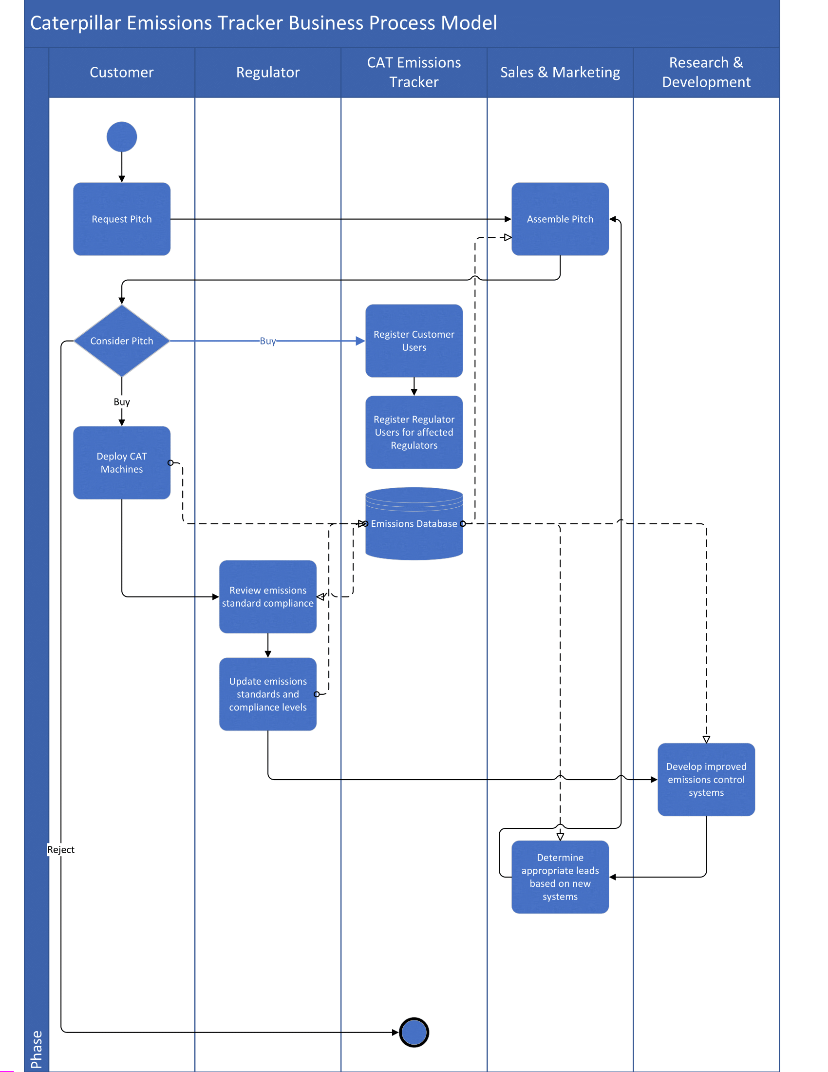(Business Process Model)

## Solution Review

2.1.

Emissions data includes amounts of nitrogen oxides, carbon monoxide, hydrocarbons, and particulate matter released during operation from more than a million machines distributed across the globe in different countries. While the data collected is all structured, the volume and velocity of the collection is expected to remain high. We considered as potential alternatives to the proposed solution the use of graph, document, and in-memory NoSQL databases and the relational/object model.

The NoSQL databases allow nonstandard data models that prioritize highly networked data, hierarchical data, or complex object data structures. A graph database tracks relationships as a primary focus, which would be useful for collating connections between machines, our multinational customers, and the varied jurisdictions they are operating in, but we expect the bulk of our data to be machine-specific emissions records, which should not require cardinalities incompatible with the relational model (Google, n.d.). A document model like XML can be used to create semi-structured elements in a tree structure, populating child nodes down from top-level elements like customer and condensing emissions data without requiring predefinition of recorded detection outputs. This model could work well, but the hierarchy cannot be conveniently redefined to examine data from other perspectives like jurisdiction; this is more inflexible than necessary for querying purposes (GeeksforGeeks, 2024). Object-oriented databases were a particularly technical consideration because they support class defined objects rather than tables; we could store a machine's sensor readouts in a form that supports functional methods to return a desired subset or transformation of the readouts for specific purposes like total carbon emissions. Ultimately, we decided against the object-oriented model because such a database would require bespoke querying methods, significantly extending development time (MongoDB, n.d.).

A potential compromise between the flexibility of the object-oriented database and its NoSQL nature is the relational/object model, which commits to a predefined schema to support relational organization of the objects in the database. While completely new classes cannot be added, this model still supports inheritance of classes and limited SQL querying of the database (Oracle, n.d.). The deciding factor here is that the hybrid database's object data structures require more processing for the most heavily populous data in the project.

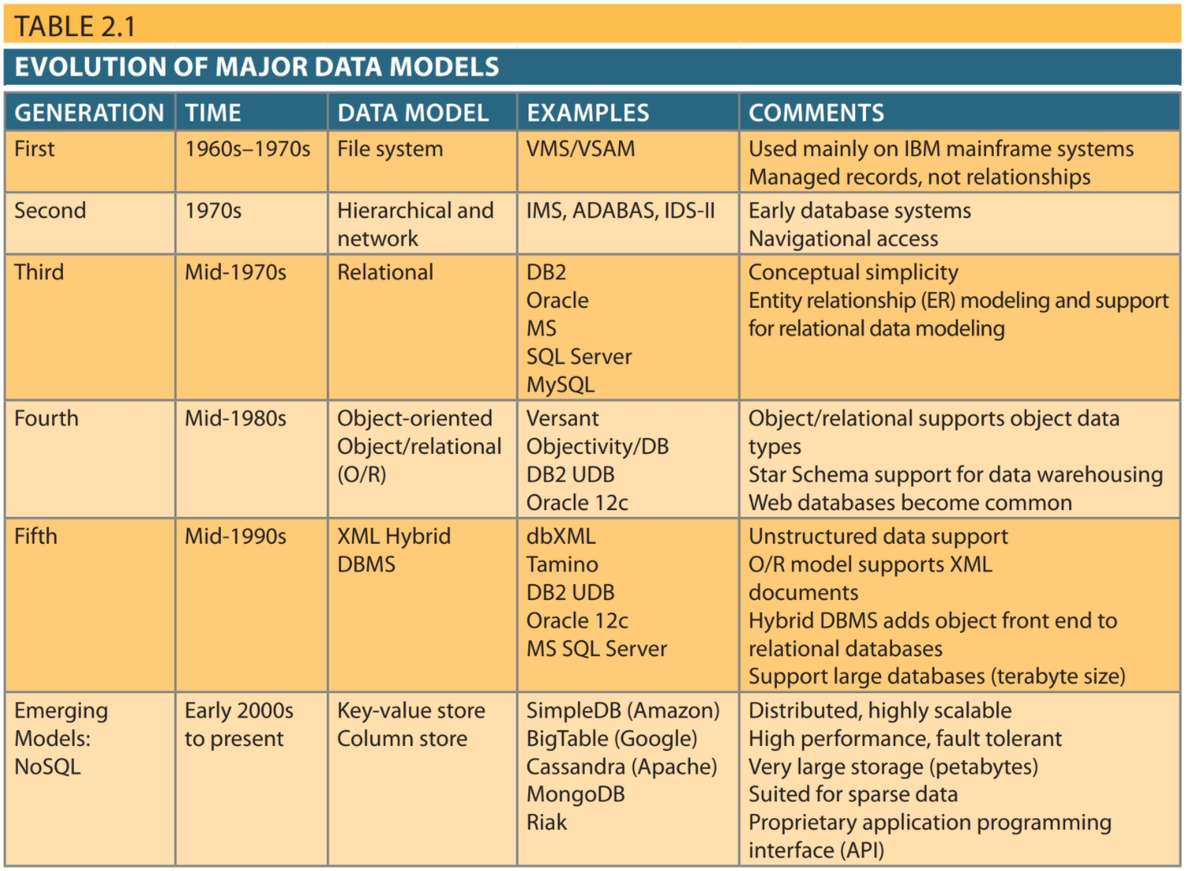

2.2.

The relational data model offers a simple way to organize emissions data logically alongside the relevant actors, and it has considerable value for promoting data consistency and accuracy; machines cannot accidentally log duplicate emissions readings or interfere with other records (Oracle, 2025). In addition to these factors, the relational model is familiar to Caterpillar, which incorporates relational databases into both their software development and data science arms (Caterpillar, 2025, Reqs).

## Business Rules/Assumptions/Constraints/Risks

### Business Rules

|  |
| --- |
| One EMISSION_RECORD contains emissions data for only one MACHINE. |
| One MACHINE has many EMISSION_RECORDS. |
| One EMISSION_RECORD contains emissions data for only one TIME_INTERVAL. |
| One TIME_INTERVAL contains many EMISSION_RECORDS. |
| One EMISSION_RECORD is for one CUSTOMER. |
| One CUSTOMER has many EMISSION_RECORDS. |
| One EMISSION_RECORD is for one WORKSITE. |
| One WORKSITE has many EMISSION_RECORDS. |
| One MACHINE is owned by one CUSTOMER. |
| One CUSTOMER owns many MACHINES. |
| One MACHINE is an instance of one CATPRODUCT. |
| One CATPRODUCT is manufactured into many MACHINES. |
| One MACHINE is located at one WORKSITE. |
| One WORKSITE has many MACHINES. |
| One CUSTOMER operates many WORKSITES. |
| A WORKSITE is operated by one CUSTOMER. |
| A CETUSER can create many REPORTS. |
| A REPORT is created by one CETUSER. |
| A CETUSER can be a Caterpillar, Customer, or Regulator Employee. |
| A TIME_INTERVAL uniquely defines a time frame used by both EMISSION_RECORDS and PRICE. |
| Each CATPRODUCT has associated PRICE, emissions standard, and technology specifications. |
| Each REPORT must be associated with one specific TIME_INTERVAL. |
| Each REPORT must include both the SQL query executed and the output result. |
| Each PRICE entry corresponds to a unique combination of TIME_INTERVAL and PAYMENT_TERMS. |
| A MACHINE can be tracked historically by associating it with a TIME_INTERVAL (e.g., service start date). |
| Each EM_STANDARD is defined by emissions limits for a specific PRODUCT and REGULATOR within a TERRITORY. |
| All emissions values in EMISSION_RECORD and EM_STANDARD must be non-negative FLOAT values. |
| Each CUSTOMER has a physical address recorded in the database. |
| Each WORKSITE includes a physical address and description to distinguish between operational locations. |
|  |

### Assumptions

**Operational Assumptions:**

* The organization has the necessary infrastructure to implement and maintain a relational database (Caterpillar, n.d.-b).
* There will be a team responsible for monitoring and managing the database to ensure its performance and reliability.

**Technical Assumptions:**

* The database implementation will use a relational model to ensure transaction accuracy and query efficiency.
* The database will integrate seamlessly with existing applications and APIs used by the organization.

**Data Related Assumptions:**

* The data stored within the database will be structured in a way that supports fast retrieval and processing of emissions-related information (Carson, 2024).
* Entities will have clearly defined relationships.

**Business Assumptions:**

* The organization is willing to allocate sufficient budget and resources for the implementation and maintenance of the database (Caterpillar, n.d.-b).
* The adoption of the database will provide a competitive advantage, improving the efficiency of tracking emissions, AI reports, and other related data (UNFCCC, n.d.).

### Constraints

One of the constraints that has a significant impact on that database design of the system is cost considerations. Both software and hardware are crucial when it comes to developing a database, along with personnel. Stabilizing these costs effectively is important because, to maintain a high-quality database management system, the software and hardware can have substantial costs. Another constraint is related to the user interface; creating a friendly user interface is important because it will ensure the database system is being used effectively. Time constraints also impact on this database because of the strict timeframe. Realistic time frames should be considered for each phase of the project to mitigate errors.

### Risks

|  |  |  |
| --- | --- | --- |
| **Risk** | **Description** | **Mitigation Strategy** |
| Regulatory Changes | Database compliance gets affected when there are changes in laws. | Database relevance needs to be maintained through international regulation compliance(UNFCCC, n.d.; Daly & Borenstein, 2025). |
| Database Crashes | Unexpected failures could cause downtime. | The system requires automated failover and replication together with scheduled backups (Vincent, 2025). |
| Data Consistency Issues | A data inconsistency can emerge from diverse datasets stored in different systems. | The system requires eventual consistency models together with conflict and version control (Carson, 2024). |
| Security Risks | Data breaches or unauthorized access. | Access controls and encryption, as well as audit systems, must be implemented (Vincent, 2024). |
| Infrastructure Constraints | Limited resources may affect performance. | cloud-based solutions or traditional on-premises implementation needs to be performed to determine scalability capabilities (Vincent, 2024). |
| Budget Limitations | Costs may exceed initial estimates. | The system requires optimized storage solution, query efficiency and a flexible pricing structure (ProjectPractical, 2023). |

## Database Design

### Entities and Attributes

**Data Dictionary**

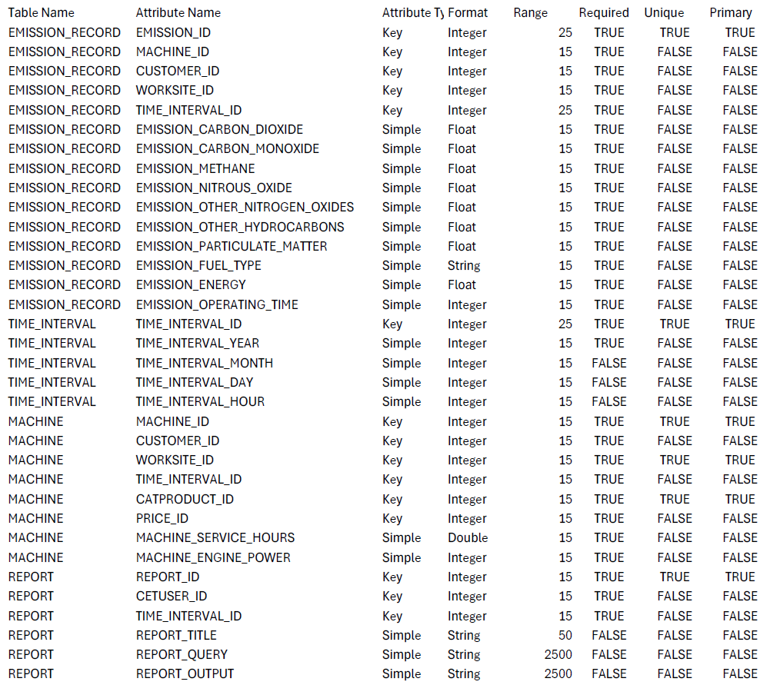

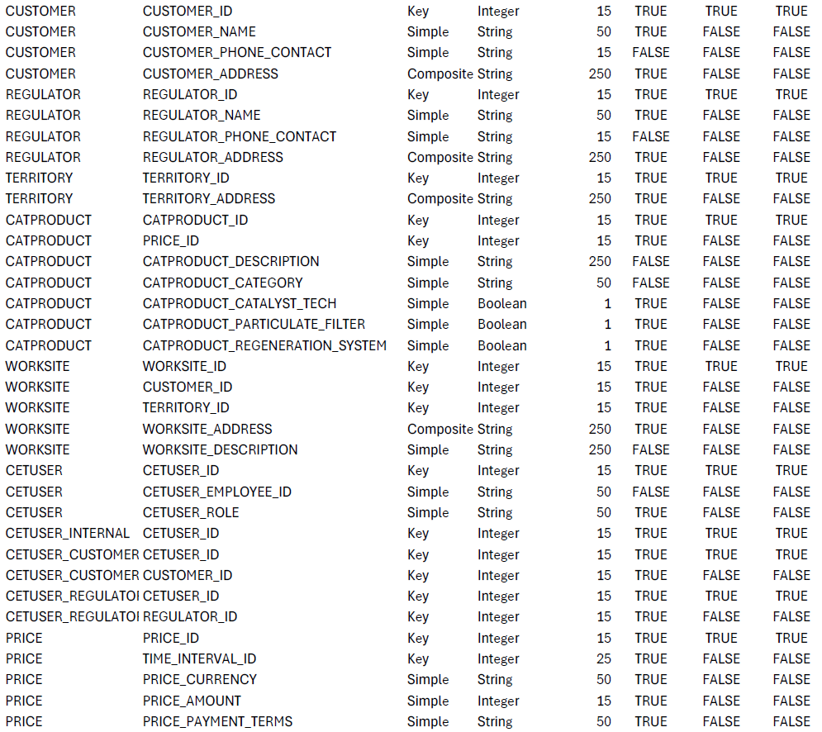

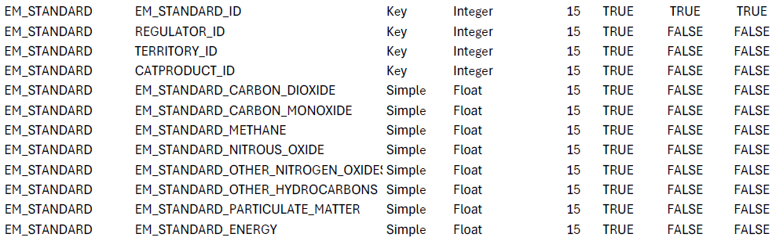

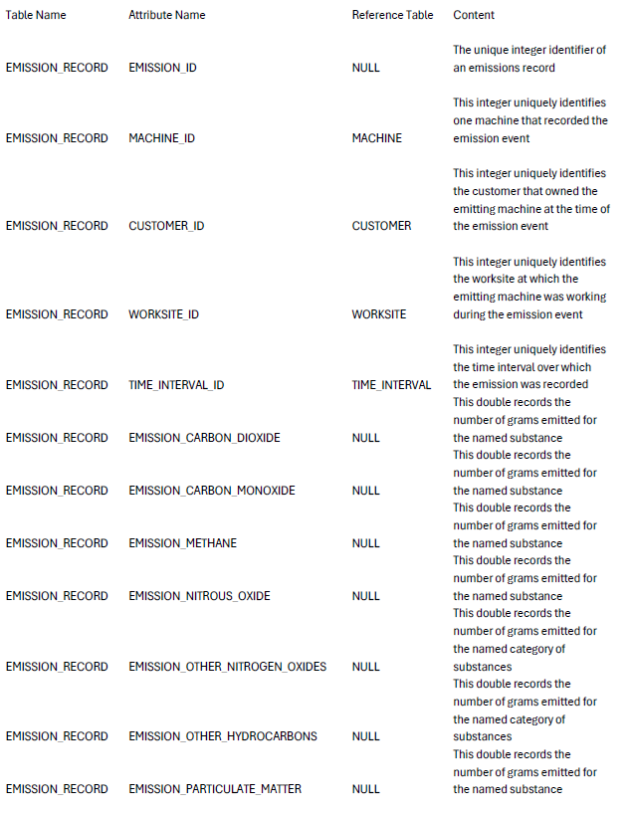

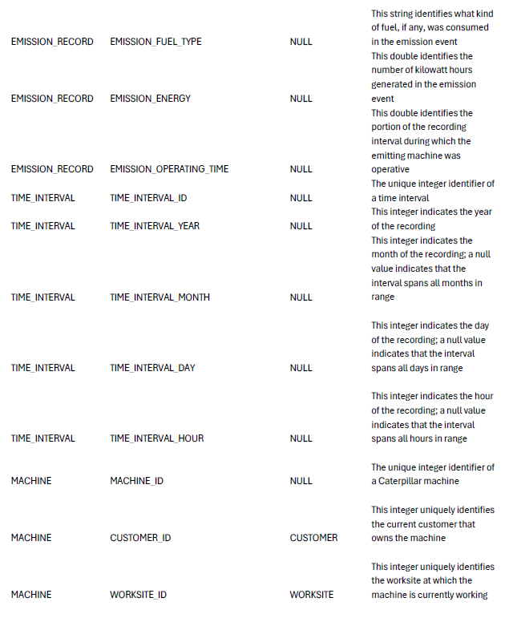

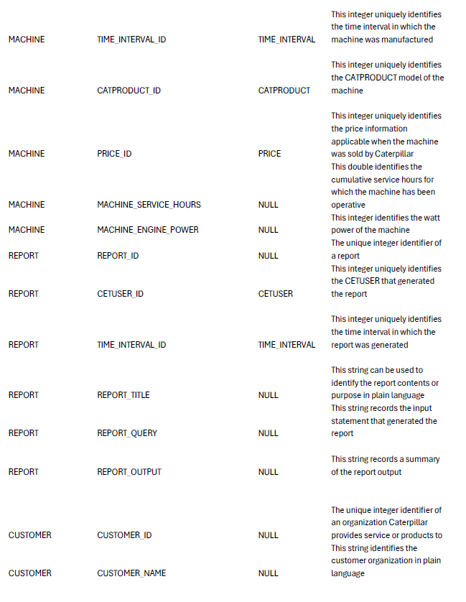

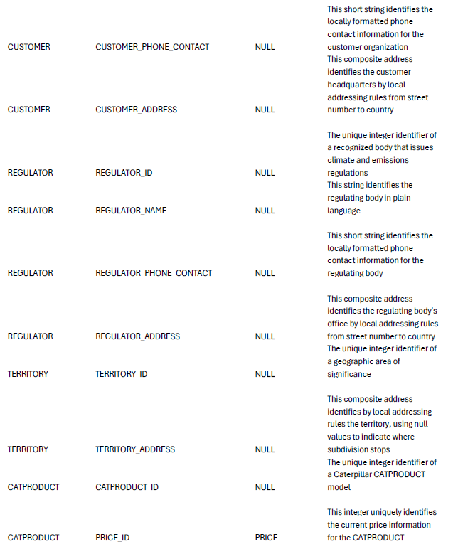

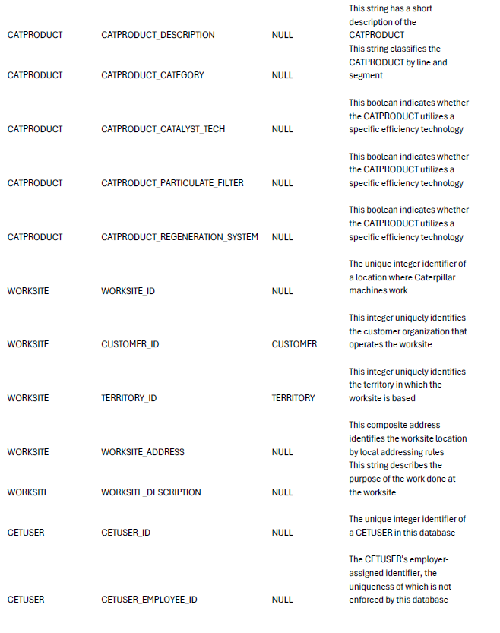

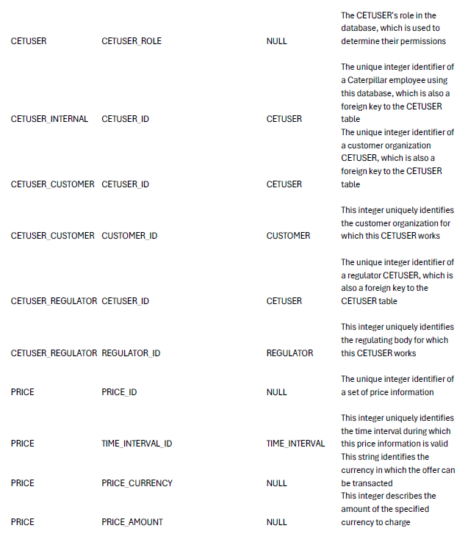

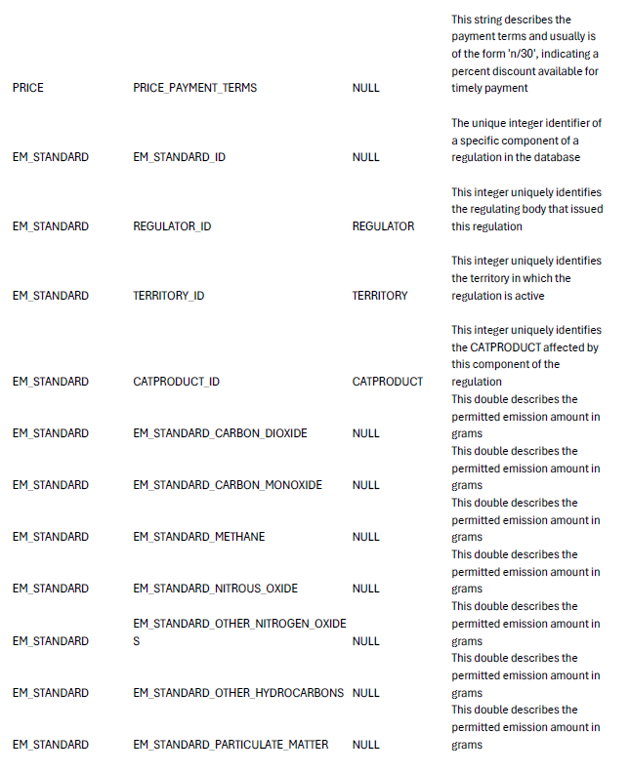

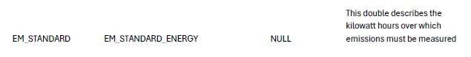

### Entity Relationship Diagram

### Relational Schema

**Referential Integrity**

EMISSION_RECORD.MACHINE_ID FK -> MACHINE.MACHINE_ID PK

EMISSION_RECORD.CUSTOMER_ID FK -> CUSTOMER.CUSTOMER_ID PK

EMISSION_RECORD.WORKSITE_ID FK -> WORKSITE.WORKSITE_ID PK

EMISSION_RECORD.TIME_INTERVAL_ID FK -> TIME_INTERVAL.TIME_INTERVAL_ID PK

MACHINE.CUSTOMER_ID FK -> CUSTOMER.CUSTOMER_ID PK

MACHINE.PRODUCT_ID FK -> PRODUCT.PRODUCT_ID PK

MACHINE.WORKSITE_ID FK -> WORKSITE.WORKSITE_ID PK

MACHINE.TIME_INTERVAL_ID FK -> TIME_INTERVAL.TIME_INTERVAL_ID PK

MACHINE.PRICE_ID FK -> PRICE.PRICE_ID PK

REPORT.USER_ID FK -> USER.USER_ID PK

REPORT.TIME_INTERVAL_ID FK -> TIME_INTERVAL.TIME_INTERVAL_ID PK

EM_STANDARD.REGULATOR_ID FK -> REGULATOR.REGULATOR_ID PK

EM_STANDARD.TERRITORY_ID FK -> TERRITORY.TERRITORY_ID PK

EM_STANDARD.PRODUCT_ID FK -> PRODUCT.PRODUCT_ID PK

WORKSITE.CUSTOMER_ID FK -> CUSTOMER.CUSTOMER_ID PK

USER.CUSTOMER_ID FK -> CUSTOMER.CUSTOMER_ID PK

USER.REGULATOR_ID FK -> REGULATOR.REGULATOR_ID PK

PRICE.TIME_INTERVAL_ID FK -> TIME_INTERVAL.TIME_INTERVAL_ID PK

**Tables & Attributes**

**Database Logical Design**

**EMISSION_RECORD**

|  |  |  |  |  |
| --- | --- | --- | --- | --- |
| EMISSION_ID | MACHINE_ID | CUSTOMER_ID | WORKSITE_ID | TIME_INTERVAL_ID |
| EMISSION_CARBON_DIOXIDE | EMISSION_CARBON MONOXIDE | EMISSION_METHANE | EMISSION_NITROUS_OXIDE | EMISSION_OTHER_NITROGEN_OXIDES |
| EMISSION_OTHER_HYDROCARBONS | EMISSION_PARTICULATE_MATTER | EMISSION_FUEL_TYPE | EMISSION_ENERGY | EMISSION_OPERATING_TIME |

**MACHINE**

|  |  |  |  |
| --- | --- | --- | --- |
| MACHINE_ID | CUSTOMER_ID | PRODUCT_ID | WORKSITE_ID |
| TIME_INTERVAL_ID | PRICE_ID | MACHINE_SERVICE_HOURS | MACHINE_ENGINE_POWER | |

**CUSTOMER**

|  |  |  |
| --- | --- | --- |
| CUSTOMER_ID | CUSTOMER_NAME | CUSTOMER_ADDRESS |
| CUSTOMER_PHONE_CONTACT |

**WORKSITE**

|  |  |  |  |
| --- | --- | --- | --- |
| WORKSITE_ID | CUSTOMER_ID | WORKSITE_ADDRESS | WORKSITE_DESCRIPTION |

**TIME_INTERVAL**

|  |  |  |
| --- | --- | --- |
| TIME_INTERVAL_ID | TIME_INTERVAL_YEAR | TIME_INTERVAL_MONTH |
| TIME_INTERVAL_DAY | TIME_INTERVAL_HOUR |

**USER**

|  |  |  |  |
| --- | --- | --- | --- |
| USER_ID | CUSTOMER_ID | REGULATOR_ID | USER_INFO |
| USER_EMPLOYEE_ID | USER_ROLE |

**REGULATOR**

|  |  |  |
| --- | --- | --- |
| REGULATOR_ID | REGULATOR_NAME | REGULATOR_ADDRESS |
| REGULATOR_PHONE_CONTACT |

**REPORT**

|  |  |  |  |  |
| --- | --- | --- | --- | --- |
| REPORT_ID | USER_ID | TIME_INTERVAL_ID | REPORT_TITLE | REPORT_QUERY |
| REPORT_OUTPUT |

**EM_STANDARD**

|  |  |  |  |  |
| --- | --- | --- | --- | --- |
| EM_STANDARD_ID | REGULATOR_ID | TERRITORY_ID | PRODUCT_ID | EM_STANDARD_CARBON |
| EM_STANDARD_METHANE | EM_STANDARD_NITROUS | EM_STANDARD_OTHER | EM_STANDARD_PARTICULATE | EMISSION_ENERGY |

**TERRITORY**

|  |  |  |
| --- | --- | --- |
| TERRITORY_ID | TERRITORY_ADDRESS | TERRITORY_STREET |
| TERRITORY_STATE | TERRITORY_STATE | TERRITORY_COUNTRY |

**PRICE**

|  |  |  |
| --- | --- | --- |
| PRICE_ID | TIME_INTERVAL_ID | PRICE_DETAILS |
| PRICE_CURRENCY | PRICE_PAYMENT_TERMS |

**PRODUCT**

|  |  |  |
| --- | --- | --- |
| PRODUCT_ID | PRICE_ID | PRODUCT_DESCRIPTION |
| PRODUCT_CATEGORY | PRODUCT_CATALYST_TECH | PRODUCT_PARTICULATE_FILTER |
| PRODUCT_REGENERATION_SYSTEM |

**Functional Dependency Analysis for Normalization**

**EMISSION_RECORD table**

**Primary key:** EMISSION_ID

**Foreign keys:** MACHINE_ID, CUSTOMER_ID, WORKSITE_ID, TIME_INTERVAL_ID

**Non-key attributes:** EMISSION_CARBON_DIOXIDE, EMISSION_CARBON MONOXIDE, EMISSION_METHANE, EMISSION_NITROUS_OXIDE, EMISSION_OTHER_NITROGEN_OXIDES, EMISSION_OTHER_HYDROCARBONS, EMISSION_PARTICULATE_MATTER, EMISSION_FUEL_TYPE, EMISSION_ENERGY, EMISSION_OPERATING_TIME

**Functional dependencies:**

**Primary key Dependency:**

EMISSION_ID -> {MACHINE_ID, CUSTOMER_ID, WORKSITE_ID, EMISSION_CARBON_DIOXIDE, EMISSION_CARBON MONOXIDE, EMISSION_METHANE, EMISSION_NITROUS_OXIDE, EMISSION_OTHER_NITROGEN_OXIDES, EMISSION_OTHER_HYDROCARBONS, EMISSION_PARTICULATE_MATTER, EMISSION_FUEL_TYPE, EMISSION_ENERGY, EMISSION_OPERATING_TIME}

**TIME_INTERVAL table**

**Primary key:** TIME_INTERVAL_ID

**Non-key attributes:** TIME_INTERVAL_YEAR, TIME_INTERVAL_MONTH, TIME_INTERVAL_DAY, TIME_INTERVAL_HOUR

**Functional dependencies:**

**Primary Key Dependency:**

TIME_INTERVAL_ID -> {TIME_INTERVAL_YEAR, TIME_INTERVAL_MONTH, TIME_INTERVAL_DAY, TIME_INTERVAL_HOUR}

**MACHINE table**

**Primary key**: MACHINE_ID

**Foreign keys:** CUSTOMER_ID, PRODUCT_ID, WORKSITE_ID, TIME_INTERVAL_ID, PRICE_ID

**Non-key attributes:** MACHINE_SERVICE_HOURS, MACHINE_ENGINE_POWER,

**Functional dependencies:**

**Primary Key Dependency:**

MACHINE_ID -> {CUSTOMER_ID, PRODUCT_ID, WORKSITE_ID, TIME_INTERVAL_ID, PRICE_ID, MACHINE_TYPE, MACHINE_SERVICE_HOURS, MACHINE_ENGINE_POWER}

**REPORT table**

**Primary key:** REPORT_ID

**Foreign keys:** USER_ID, TIME_INTERVAL_ID

**Non-key attributes:** REPORT_TITLE, REPORT_QUERY, REPORT_OUTPUT

**Functional dependencies:**

**Primary Key Dependency:**

REPORT_ID -> {REPORT_TITLE, REPORT_QUERY, REPORT_OUTPUT, USER_ID, TIME_INTERVAL_ID}

**CUSTOMER table**

**Primary key:** CUSTOMER_ID

**Non-key attributes:** CUSTOMER_NAME, CUSTOMER_ADDRESS, CUSTOMER_PHONE_CONTACT

**Functional dependencies:**

**Primary Key Dependency:**

CUSTOMER_ID -> {CUSTOMER_NAME, CUSTOMER_ADDRESS, CUSTOMER_PHONE_CONTACT}

**REGULATOR table**

**Primary key:** REGULATOR_ID

**Non-key attributes:** REGULATOR_NAME, REGULATOR_ADDRESS, REGULATOR_PHONE_CONTACT

**Functional dependencies:**

**Primary Key Dependency:**

REGULATOR_ID -> {REGULATOR_NAME, REGULATOR_ADDRESS, REGULATOR_PHONE_CONTACT}

**EM_STANDARD table**

**Primary key:** EM_STANDARD_ID

**Foreign keys:** REGULATOR_ID, TERRITORY_ID, PRODUCT_ID

**Non-key attributes:** EMISSION_CARBON_DIOXIDE, EMISSION_CARBON_MONOXIDE, EMISSION_METHANE, EMISSION_NITROUS_OXIDE, EMISSION_OTHER_NITROGEN_OXIDES, EMISSION_OTHER_HYDROCARBONS, EMISSION_PARTICULATE_MATTER, EMISSION_ENERGY

**Functional dependencies:**

**Primary Key Dependency:**

EM_STANDARD_ID -> { REGULATOR_ID, TERRITORY_ID, PRODUCT_ID, EMISSION_CARBON_DIOXIDE, EMISSION_CARBON_MONOXIDE, EMISSION_METHANE, EMISSION_NITROUS_OXIDE, EMISSION_OTHER_NITROGEN_OXIDES, EMISSION_OTHER_HYDROCARBONS, EMISSION_PARTICULATE_MATTER}

**TERRITORY table**

**Primary key:** TERRITORY_ID

**Non-key attributes:** TERRITORY_ADDRESS

**Functional dependencies:**

**Primary Key Dependency:**

TERRITORY_ID -> {TERRITORY_ADDRESS}

**PRODUCT table**

**Primary key:** PRODUCT_ID

**Foreign keys:** PRICE_ID

**Non-key attributes:** PRODUCT_DESCRIPTION, PRODUCT_CATEGORY, PRODUCT_CATALYST_TECH, PRODUCT_PARTICULATE_FILTER, PRODUCT_REGENERATION_SYSTEM

**Functional dependencies:**

**Primary Key Dependency:**

PRODUCT_ID -> {PRODUCT_DESCRIPTION, PRODUCT_CATEGORY, PRODUCT_CATALYST_TECH, PRODUCT_PARTICULATE_FILTER, PRODUCT_REGENERATION_SYSTEM}

**WORKSITE table**

**Primary key:** WORKSITE_ID

**Foreign key:** CUSTOMER_ID, TERRITORY_ID

**Non-key attributes:** WORKSITE_ADDRESS, WORKSITE_DESCRIPTION

**Functional dependencies:**

**Primary Key Dependency:**

WORKSITE_ID -> {CUSTOMER_ID, TERRITORY_ID, WORKSITE_ADDRESS, WORKSITE_DESCRIPTION, WORKSITE_TYPE}

**CETUSER table**

**Primary key:** CETUSER_ID

**Non-key attributes:** CETUSER_ROLE

**Functional dependencies:**

**Primary Key Dependency:**

CETUSER_ID -> {CETUSER_ROLE}

**Supertype-Subtype Dependencies:**

CETUSER -> {CETUSER_CUSTOMER, CETUSER_REGULATOR}

CETUSER_ID (for CETUSER_CUSTOMER) -> {CUSTOMER_ID}

CETUSER_ID (for CETUSER_REGULATOR) -> {REGULATOR_ID}

**PRICE table**

**Primary key:** PRICE_ID

**Foreign key:** TIME_INTERVAL_ID

**Non-key attributes:** PRICE_CURRENCY, PRICE_PAYMENT_TERMS, PRICE_AMOUNT

**Functional dependencies:**

**Primary Key Dependency:**

PRICE_ID -> {TIME_INTERVAL_ID, PRICE_CURRENCY, PRICE_PAYMENT_TERMS, PRICE_AMOUNT}

**RELATIONAL SCHEMA IN 3NF**

**EMISSION_RECORD:**

**EMMISION_RECORD (3NF)**

|  |  |  |
| --- | --- | --- |
| EMISSION_ID | MACHINE_ID | CUSTOMER_ID |
| WORKSITE_ID | TIME_INTERVAL_ID | EMISSION_CARBON_DIOXIDE |
| EMISSION_CARBON MONOXIDE | EMISSION_METHANE | EMISSION_NITROUS_OXIDE |
| EMISSION_OTHER_NITROGEN_OXIDES | EMISSION_OTHER_HYDROCARBONS | EMISSION_PARTICULATE_MATTER |
| EMISSION_FUEL_TYPE | EMISSION_ENERGY | EMISSION_OPERATING_TIME |

**TIME_INTERVAL:**

**TIME_INTERVAL (3NF)**

|  |  |  |
| --- | --- | --- |
| TIME_INTERVAL_ID | TIME_INTERVAL_YEAR | TIME_INTERVAL_MONTH |
| TIME_INTERVAL_DAY | TIME_INTERVAL_HOUR |

**MACHINE:**

**MACHINE (3NF)**

|  |  |  |  |
| --- | --- | --- | --- |
| MACHINE_ID | CUSTOMER_ID | PRODUCT_ID | WORKSITE_ID |
| TIME_INTERVAL_ID | PRICE_ID | MACHINE_SERVICE_HOURS | MACHINE_ENGINE_POWER | |

**REPORT:**

**REPORT (3NF)**

|  |  |  |  |  |
| --- | --- | --- | --- | --- |
| REPORT_ID | USER_ID | TIME_INTERVAL_ID | REPORT_TITLE | REPORT_QUERY |
| REPORT_OUTPUT |

**CUSTOMER:**

**CUSTOMER (3NF)**

|  |  |  |  |
| --- | --- | --- | --- |
| CUSTOMER_ID | CUSTOMER_NAME | CUSTOMER_ADDRESS | CUSTOMER_PHONE_CONTACT |

**REGULATOR:**

**REGULATOR (3NF)**

|  |  |  |  |
| --- | --- | --- | --- |
| REGULATOR_ID | REGULATOR_NAME | REGULATOR_ADDRESS | REGULATOR_PHONE_CONTACT |

**EM_STANDARD:**

**EM_STANDARD (3NF)**

|  |  |  |  |  |
| --- | --- | --- | --- | --- |
| EM_STANDARD_ID | REGULATOR_ID | TERRITORY_ID | PRODUCT_ID | EMISSION_CARBON_DIOXIDE |
| EMISSION_CARBON_MONOXIDE | EMISSION_METHANE | EMISSION_NITROUS_OXIDE | EMISSION_OTHER_NITROGEN_OXIDES | EMISSION_OTHER_HYDROCARBONS |
| EMISSION_PARTICULATE_MATTER | EMISSION_ENERGY |

**TERRITORY:**

**TERRITORY (3NF)**

|  |  |
| --- | --- |
| TERRITORY_ID | TERRITORY_ADDRESS |

**PRODUCT:**

**PRODUCT (3NF)**

|  |  |  |
| --- | --- | --- |
| PRODUCT_ID | PRICE_ID | PRODUCT_DESCRIPTION |
| PRODUCT_CATEGORY | PRODUCT_CATALYST_TECH | PRODUCT_PARTICULATE_FILTER |
| PRODUCT_REGENERATION_SYSTEM |

**WORKSITE:**

**WORKSITE (3NF)**

|  |  |  |  |  |
| --- | --- | --- | --- | --- |
| WORKSITE_ID | TERRITORY_ID | CUSTOMER_ID | WORKSITE_ADDRESS | WORKSITE_DESCRIPTION |

**CETUSER:**

**CETUSER (3NF)**

|  |  |
| --- | --- |
| USER_ID | USER_ROLE |

**CETUSER_CUSTOMER (3NF)**

|  |  |
| --- | --- |
| USER_ID | CUSTOMER_ID |

**CETUSER_REGULATOR (3NF)**

|  |  |
| --- | --- |
| USER_ID | REGULATOR_ID |

**PRICE:**

**PRICE (3NF)**

|  |  |  |  |  |
| --- | --- | --- | --- | --- |
| PRICE_ID | TIME_INTERVAL_ID | PRICE_CURRENCY | PRICE_PAYMENT_TERMS | PRICE_AMOUNT |

## 5. Implementation

### 5.1 Create and Update Tables

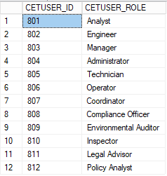

(CETUSER table)

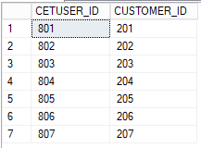

(CETUSER table for customers)

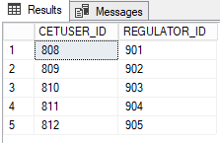

(CETUSER table for REGULATOR)

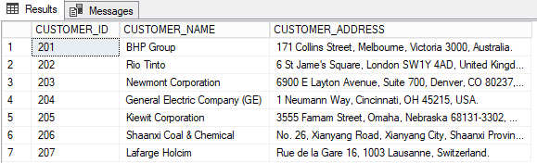

(CUSTOMER table)

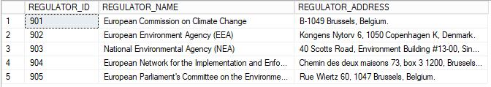(REGULATOR table)

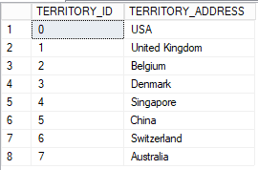

(TERRITORY table)

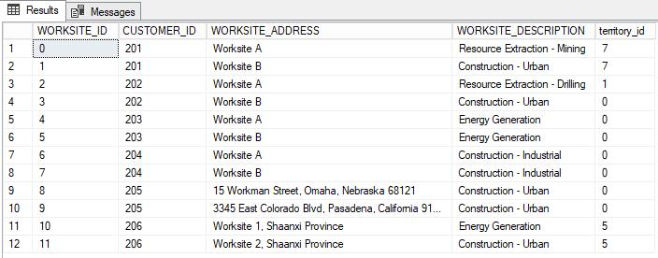(WORKSITE table)

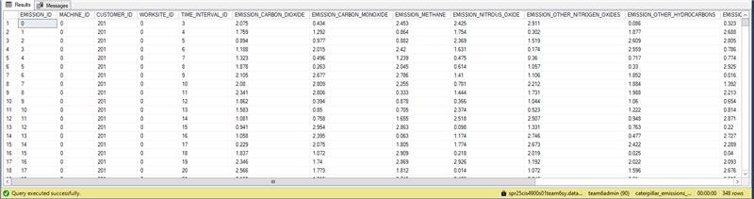(EMISSIONS table)

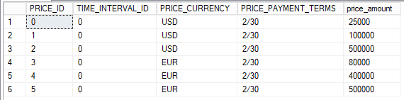

(PRICE table)

(PRODUCT table)

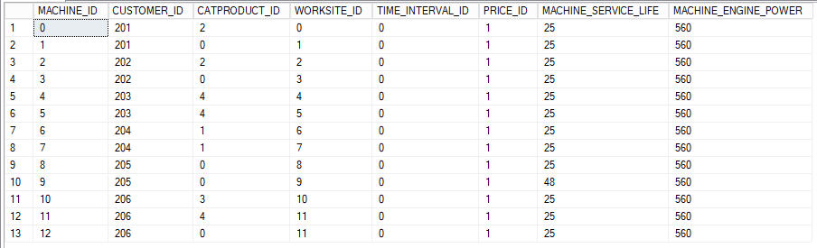(MACHINE table)

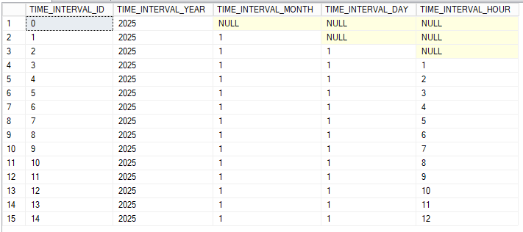(TIME table)

### 5.2 Reports

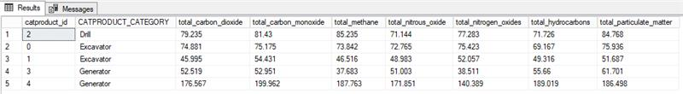(This report uses a join query that aggregates all emissions recorded for the year 2025 by the emitting product model for marketing and research direction.)

This report is useful for stakeholders because it provides the overall environmental footprint, and it can also identify substantial sources of pollution. Many of the emissions and gases within the report are major contributors to global warming and cause serious health effects. Therefore, this report can help pick out the CAT product that needs stricter emission controls.

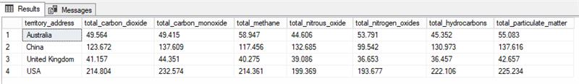(This report aggregates emissions according to the nation in which they were emitted.)

This report specifies the total emissions according to the nation. Global emission standards are global and can be stricter in some nations, therefore it is important for CAT to ensure their equipment meets the corresponding standards.



(This rep lists worksites and whether they are compliant with the applicable emission standards for specific substances.)

This report is significant for CAT because it shows if the worksite is following the applicable emission standards. CAT can prevent substantial legal fees if they are aware which worksite is not complying with the emission standards. CAT is a large corporation that has their machines on thousands of worksites. Having an efficient record of the worksite and their relationship with the emission standards will prevent expensive fines.

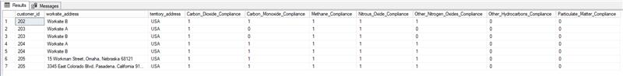(The same report as above, with worksites divided by the customer operating them.)

Similarly to the report above, expect this report is divided by the customer operating them. If CAT identifies a worksite that is not compliant with the emission standards, they need to know the customer that is responsible. This will help them get in contact with the customer and communicate a strategy to stay within the emission standards.

(This report indicates whether a company in the U.S complies with emission targets.)

A significant amount of CAT customers is located within the U.S. Therefore, keeping track of the companies in the U.S and their relationship with the emission targets is important. It can prevent companies from exceeding the emission target.

6. Database Administration and Monitoring  
*Instructions: Within the following sub-sections, describe the requirements and strategies*  
*to maintain the database operationally considering the following:*  
*• Backup and recovery strategies needed to implement the DDD.*  
*• Any security and/or privacy considerations.*  
6.1 Roles and Responsibilities

Caterpillar bears overall administrative responsibility for the database, although certain components of role-based access and uptime are delegated to client organizations who register users in the database and/or operate CAT machines. Caterpillar’s responsibilities are divided among the database administrator, the system administrator, and the security administrator.

The system administrator is responsible for guaranteeing the availability of the Emissions Tracker database system. The system is provisioned through Microsoft Azure’s virtual hyperscale services, but the compatibility of the reporting hardware and software in CAT machines operating in remote locations with the Azure service must be carefully maintained. Customers operating CAT machines are responsible for facilitating service calls for individual machines, but the system administrator must determine and implement the appropriate solutions for novel challenges to service availability (Shiff, 2022).

The database administrator is responsible for guaranteeing the integrity of the Emissions Tracker data, ensuring that the data model supports the data collected and the reports that may be needed about that data. This responsibility extends to providing appropriate enforcement of business rules using constraints and triggered behaviors (Madden, 2023).

The security administrator is responsible for the confidentiality of the Emissions Tracker database. This includes internal controls over Caterpillar’s own employee access to the database and verification of which external client administrators have permission to add and remove users and what access permissions they have. It is critical for the trade secrets of Caterpillar and its customers that external users can only access the necessary data for their needs (Shiff, 2022).

Specific administration skill requirements applicable to the database include cloud infrastructure expertise. Familiarity with platforms like Microsoft Azure is crucial, especially with tools like deployment and scaling within the cloud environment. Having problem-solving skills like the capacity to identify and fix hardware or software compatibility problems, particularly for computers running in difficult or remote environments, is critical. According to Manikandan (2025), a system administrator must manage several tasks and depending on the systems the manager must be knowledgeable in various areas. As mentioned for this database a strong understanding of cloud infrastructure management, specifically Microsoft Azure, is required.

Regarding the database administrator, some specific skills are expertise in developing and maintaining a data model that meets the organizational needs. According to Teal HQ (2025), a significant skill includes being able to design and execute disaster recovery and business continuity plan. Many businesses depend on uninterrupted data access, which is why it is important to minimize downtime.

The skills needed for the security administrator include knowledge of encryption and secure authentication techniques, as well as familiarity with best practices for protecting sensitive data. Incident response is also an important skill needed, having the ability to respond effectively to breaches or potential threats. Knowledge of the best practices to protect sensitive data, like encryption, within the database is also vital. According to Webb (2022), Managing firewalls, developing security policies, and monitoring activity on the network are the key skills of a security administrator. This role is important because it safeguards the database and maintains a secure environment.

6.2 Security and Privacy  
**Security and Privacy**

All database elements including schema, sub-schema, tables, and data records need strong protection and integrity to function properly in the Caterpillar Emissions Tracker system. Security measures implement full control of access management together with auditing capabilities and visibility features for all database assets. According to Database System Concepts, “access to data must be controlled to ensure that users only access data that they are authorized to see or manipulate” (Silberschatz, Korth, & Sudarshan, 2020, p. 646), which supports the core of the team’s design. The database schema developed in the implementation phase (section 5) can be logically grouped into several sub-schemas that guide the implementation of these security principles. The **Emissions Data sub-schema** maintains records for emissions standards while **User Management sub-schema** defines role-based access control protocols and **Reporting sub-schema** supports audit features for reports and query execution and finally **Customer and Worksite sub-schema** restricts data access according to user ownership and **Machine and Product sub-schema** ensures asset-emission relations. These structures provide the base through which static access restrictions together with data validation and system utilization tracking are enabled across the entire platform.

**User Access Management**

CETUSER implements user identity and role separation by establishing structures for each person to join as a customer or regulator or Caterpillar employee. The system gives permissions according to how users relate to the organization. As Silberschatz, Korth, and Sudarshan (2020) state: “Authorization in a database system is the process of granting or denying access to data and operations to users or user groups. The system must ensure that only authorized users can perform actions on the data” (p.229) Reports can be generated by authorized personnel, yet backend administrative operations retain the authority to insert and modify emissions records simultaneously.

**View Definition for Controlled Data Access**

Creating SQL views helps users access data according to their defined roles. Harrington (2024) explains that “views allow the database administrator to restrict access to certain data by presenting users only with the columns and rows they are authorized to see” (p. 231). Through this project developers can establish views that expose relevant emissions data for precise worksites while shielding confidential information regarding pricing and regulatory thresholds unless authorized access is provided.

**DBMS Access Control with Granularity**

The security system operates through GRANT and REVOKE statements to define user privileges at different data levels for SELECT, INSERT, UPDATE or DELETE operations. According to Oracle (2021), “Oracle Virtual Private Database (VPD) creates security policies to control database access at the row and column level.” In this implementation, the system extends such access policies not only to records, but also to elements like stored reports and pricing models to ensure that internal calculations and emissions thresholds cannot be altered without authorization.

**DBMS Usage Monitoring and Audit Trails**

Database security heavily depends on usage monitoring systems. The REPORT table contains logged report generation queries alongside their associated SQL query (REPORT_QUERY) and display results (REPORT_OUTPUT). Silberschatz, Korth, and Sudarshan (2020) emphasize that, “Applications must log actions to an audit trail, to detect who carried out an update, or accessed some sensitive data. Audit trails are used after-the-fact to detect security breaches, repair damage caused by security breach, and trace who carried out the breach” (p. 774). The database design supports operational insight and regulatory compliance by allowing internal audits of user actions.

**Integrity Across all Data Components**

**Schema**

The Schema system controls user access limitations by separating different entity categories like CUSTOMER from REGULATOR roles.

**Sub-schema/Views**

The system allows access to essential data through defined read-only, e.g., emissions reports.

**Tables/Records**

User role determines the available read access through read-only views but users get restricted write access to tables and records.

**Files/Partitions**

The cloud-based DBMS manages physical storage through data partitioning while ensuring encryption and safe replication capabilities.

**Relations**

Foreign key integrity enforces logical consistency across EMISSION_RECORD data and its associated entities

**Data Elements**

The system enforces data element constraints such as positive numeric value requirements for fields including emissions and energy measurements.

**Tools to support security and privacy requirements**

A tool that is needed to protect the sensitive data that is in transit or just at rest is encryption. As Sheldon (2024) states, encryption makes sure that the threat actors or unauthorized third parties are not able to understand the data in the event they gain access to it. For this database the sensitive data that will need to be encrypted will be the emission measurements and customer details. Next, auditing and monitoring tools are essential because they help analyze user activity, database interactions, and system changes. This will help mitigate and detect threats or breaches in real time. Data masking tools are also an important tool to have because they can protect sensitive data while allowing limited visibility.

6.3 Backup and Recovery

Backing up of the Emissions Tracker data is divided into Azure Storage Redundancy, Caterpillar-managed Cold Storage, and CAT Local Storage. Microsoft Azure, as the enterprise host for the database, provides geo-redundant replication of the database across distinct regions with read access always available. In the event of a localized outage that interrupts service to the primary region, the database can failover to a secondary region to enable full write access after a short transition period. Caterpillar updates, monthly, a cold magnetic tape backup of the entire database versioned over the preceding twelve months to address the possibility of a complete failure of Azure supported services. To provide an appropriate allowance for recovery from such failures, all reporting CAT machines contain local storage of their reported data for up to a year of operation. The failover region service or a complete service replacement based on Caterpillar’s backup can request all unreported data without a loss of any data within the work recovery time (Microsoft, 2025)

Appendix A: SQL and Reports

**CREATE TABLE queries**

CREATE TABLE TIME_INTERVAL (

TIME_INTERVAL_ID INT PRIMARY KEY,

TIME_INTERVAL_YEAR INT,

TIME_INTERVAL_MONTH INT,

TIME_INTERVAL_DAY INT,

TIME_INTERVAL_HOUR INT

);

CREATE TABLE CUSTOMER (

CUSTOMER_ID INT PRIMARY KEY,

CUSTOMER_NAME VARCHAR(100),

CUSTOMER_ADDRESS VARCHAR(100)

);

CREATE TABLE REGULATOR (

REGULATOR_ID INT PRIMARY KEY,

REGULATOR_NAME VARCHAR(100),

REGULATOR_ADDRESS VARCHAR(100)

);

CREATE TABLE CETUSER (

CETUSER_ID INT PRIMARY KEY,

CETUSER_ROLE VARCHAR(50)

);

CREATE TABLE CETUSER_CUSTOMER (

CETUSER_ID INT PRIMARY KEY FOREIGN KEY REFERENCES CETUSER(CETUSER_ID),

CUSTOMER_ID INT FOREIGN KEY REFERENCES CUSTOMER(CUSTOMER_ID)

);

CREATE TABLE CETUSER_REGULATOR (

CETUSER_ID INT PRIMARY KEY FOREIGN KEY REFERENCES CETUSER(CETUSER_ID),

REGULATOR_ID INT FOREIGN KEY REFERENCES REGULATOR(REGULATOR_ID)

);

CREATE TABLE TERRITORY (

TERRITORY_ID INT PRIMARY KEY,

TERRITORY_ADDRESS VARCHAR(100)

);

CREATE TABLE PRICE (

PRICE_ID INT PRIMARY KEY,

TIME_INTERVAL_ID INT FOREIGN KEY REFERENCES TIME_INTERVAL(TIME_INTERVAL_ID),

PRICE_CURRENCY VARCHAR(10),

PRICE_AMOUNT INT,

PRICE_PAYMENT_TERMS VARCHAR(100)

);

CREATE TABLE CATPRODUCT (

CATPRODUCT_ID INT PRIMARY KEY,

PRICE_ID INT FOREIGN KEY REFERENCES PRICE(PRICE_ID),

CATPRODUCT_CATEGORY VARCHAR(50),

CATPRODUCT_CATALYST_TECH CHAR,

CATPRODUCT_PARTICULATE_FILTER CHAR,

CATPRODUCT_REGENERATION_SYSTEM CHAR,

CATPRODUCT_DESCRIPTION TEXT

);

CREATE TABLE EM_STANDARD (

EM_STANDARD_ID INT PRIMARY KEY,

REGULATOR_ID INT FOREIGN KEY REFERENCES REGULATOR(REGULATOR_ID),

TERRITORY_ID INT FOREIGN KEY REFERENCES TERRITORY(TERRITORY_ID),

CATPRODUCT_ID INT FOREIGN KEY REFERENCES CATPRODUCT(CATPRODUCT_ID),

EMISSION_CARBON_DIOXIDE FLOAT,

EMISSION_CARBON_MONOXIDE FLOAT,

EMISSION_METHANE FLOAT,

EMISSION_NITROUS_OXIDE FLOAT,

EMISSION_OTHER_NITROGEN_OXIDES FLOAT,

EMISSION_OTHER_HYDROCARBONS FLOAT,

EMISSION_PARTICULATE_MATTER FLOAT,

EMISSION_STANDARD_UNIT_OF_MEASUREMENT VARCHAR(50)

);

CREATE TABLE WORKSITE (

WORKSITE_ID INT PRIMARY KEY,

TERRITORY_ID INT FOREIGN KEY REFERENCES TERRITORY(TERRITORY_ID),

CUSTOMER_ID INT FOREIGN KEY REFERENCES CUSTOMER(CUSTOMER_ID),

WORKSITE_ADDRESS VARCHAR(100),

WORKSITE_DESCRIPTION TEXT

);

CREATE TABLE MACHINE (

MACHINE_ID INT PRIMARY KEY,

CUSTOMER_ID INT FOREIGN KEY REFERENCES CUSTOMER(CUSTOMER_ID),

CATPRODUCT_ID INT FOREIGN KEY REFERENCES CATPRODUCT(CATPRODUCT_ID),

WORKSITE_ID INT FOREIGN KEY REFERENCES WORKSITE(WORKSITE_ID),

TIME_INTERVAL_ID INT FOREIGN KEY REFERENCES TIME_INTERVAL(TIME_INTERVAL_ID),

PRICE_ID INT FOREIGN KEY REFERENCES PRICE(PRICE_ID),

MACHINE_SERVICE_LIFE INT,

MACHINE_ENGINE_POWER INT

);

CREATE TABLE EMISSION_RECORD (

EMISSION_ID INT PRIMARY KEY,

MACHINE_ID INT FOREIGN KEY REFERENCES MACHINE(MACHINE_ID),

CUSTOMER_ID INT FOREIGN KEY REFERENCES CUSTOMER(CUSTOMER_ID),

WORKSITE_ID INT FOREIGN KEY REFERENCES WORKSITE(WORKSITE_ID),

TIME_INTERVAL_ID INT FOREIGN KEY REFERENCES TIME_INTERVAL(TIME_INTERVAL_ID),

EMISSION_CARBON_DIOXIDE FLOAT,

EMISSION_CARBON_MONOXIDE FLOAT,

EMISSION_METHANE FLOAT,

EMISSION_NITROUS_OXIDE FLOAT,

EMISSION_OTHER_NITROGEN_OXIDES FLOAT,

EMISSION_OTHER_HYDROCARBONS FLOAT,

EMISSION_PARTICULATE_MATTER FLOAT,

EMISSION_FUEL_TYPE VARCHAR(50),

EMISSION_FUEL_SPENT FLOAT,

EMISSION_OPERATING_TIME FLOAT

);

CREATE TABLE REPORT (

REPORT_ID INT PRIMARY KEY,

CETUSER_ID INT FOREIGN KEY REFERENCES CETUSER(CETUSER_ID),

TIME_INTERVAL_ID INT FOREIGN KEY REFERENCES TIME_INTERVAL(TIME_INTERVAL_ID),

REPORT_TITLE VARCHAR(100),

REPORT_QUERY TEXT,

REPORT_OUTPUT TEXT

);

**INSERT STATEMENTS**

INSERT INTO CUSTOMER (CUSTOMER_ID, CUSTOMER_NAME, CUSTOMER_ADDRESS)

VALUES (201, 'BHP Group', '171 Collins Street, Melbourne, Victoria 3000, Australia.');

INSERT INTO CUSTOMER (CUSTOMER_ID, CUSTOMER_NAME, CUSTOMER_ADDRESS)

VALUES (202, 'Rio Tinto', '6 St Jame''s Square, London SW1Y 4AD, United Kingdom.');

INSERT INTO CUSTOMER (CUSTOMER_ID, CUSTOMER_NAME, CUSTOMER_ADDRESS)

VALUES (203, 'Newmont Corporation', '6900 E Layton Avenue, Suite 700, Denver, CO 80237, USA.');

INSERT INTO CUSTOMER (CUSTOMER_ID, CUSTOMER_NAME, CUSTOMER_ADDRESS)

VALUES (204, 'General Electric Company (GE)', '1 Neumann Way, Cincinnati, OH 45215, USA.');

INSERT INTO CUSTOMER (CUSTOMER_ID, CUSTOMER_NAME, CUSTOMER_ADDRESS)

VALUES (205, 'Kiewit Corporation', '3555 Farnam Street, Omaha, Nebraska 68131-3302, USA.');

INSERT INTO CUSTOMER (CUSTOMER_ID, CUSTOMER_NAME, CUSTOMER_ADDRESS)

VALUES (206, 'Shaanxi Coal & Chemical', 'No. 26, Xianyang Road, Xianyang City, Shaanxi Province, China.');

INSERT INTO CUSTOMER (CUSTOMER_ID, CUSTOMER_NAME, CUSTOMER_ADDRESS)

VALUES (207, 'Lafarge Holcim', 'Rue de la Gare 16, 1003 Lausanne, Switzerland.');

INSERT INTO REGULATOR (REGULATOR_ID, REGULATOR_NAME, REGULATOR_ADDRESS)

VALUES (901, 'European Commission on Climate Change', 'B-1049 Brussels, Belgium.');

INSERT INTO REGULATOR (REGULATOR_ID, REGULATOR_NAME, REGULATOR_ADDRESS)

VALUES (902, 'European Environment Agency (EEA)', 'Kongens Nytorv 6, 1050 Copenhagen K, Denmark.');

INSERT INTO REGULATOR (REGULATOR_ID, REGULATOR_NAME, REGULATOR_ADDRESS)

VALUES (903, 'National Environmental Agency (NEA)', '40 Scotts Road, Environment Building #13-00, Singapore 228231');

INSERT INTO REGULATOR (REGULATOR_ID, REGULATOR_NAME, REGULATOR_ADDRESS)

VALUES (904, 'European Network for the Implementation and Enforcement of Environmental Law (IMPEL)', 'Chemin des deux maisons 73, box 3 1200, Brussels, Belgium');

INSERT INTO REGULATOR (REGULATOR_ID, REGULATOR_NAME, REGULATOR_ADDRESS)

VALUES (905, 'European Parliament''s Committee on the Environment, Public Health and Food Safety (ENVI)', 'Rue Wiertz 60, 1047 Brussels, Belgium.');

INSERT INTO CETUSER (CETUSER_ID, CETUSER_ROLE)

VALUES (801, 'Analyst');

INSERT INTO CETUSER (CETUSER_ID, CETUSER_ROLE)

VALUES (802, 'Engineer');

INSERT INTO CETUSER (CETUSER_ID, CETUSER_ROLE)

VALUES (803, 'Manager');

INSERT INTO CETUSER (CETUSER_ID, CETUSER_ROLE)

VALUES (804, 'Administrator');

INSERT INTO CETUSER (CETUSER_ID, CETUSER_ROLE)

VALUES (805, 'Technician');

INSERT INTO CETUSER (CETUSER_ID, CETUSER_ROLE)

VALUES (806, 'Operator');

INSERT INTO CETUSER (CETUSER_ID, CETUSER_ROLE)

VALUES (807, 'Coordinator');

INSERT INTO CETUSER (CETUSER_ID, CETUSER_ROLE)

VALUES (808, 'Compliance Officer');

INSERT INTO CETUSER (CETUSER_ID, CETUSER_ROLE)

VALUES (809, 'Environmental Auditor');

INSERT INTO CETUSER (CETUSER_ID, CETUSER_ROLE)

VALUES (810, 'Inspector');

INSERT INTO CETUSER (CETUSER_ID, CETUSER_ROLE)

VALUES (811, 'Legal Advisor');

INSERT INTO CETUSER (CETUSER_ID, CETUSER_ROLE)

VALUES (812, 'Policy Analyst');

INSERT INTO CETUSER_CUSTOMER (CETUSER_ID, CUSTOMER_ID)

VALUES (801, 201);

INSERT INTO CETUSER_CUSTOMER (CETUSER_ID, CUSTOMER_ID)

VALUES (802, 202);

INSERT INTO CETUSER_CUSTOMER (CETUSER_ID, CUSTOMER_ID)

VALUES (803, 203);

INSERT INTO CETUSER_CUSTOMER (CETUSER_ID, CUSTOMER_ID)

VALUES (804, 204);

INSERT INTO CETUSER_CUSTOMER (CETUSER_ID, CUSTOMER_ID)

VALUES (805, 205);

INSERT INTO CETUSER_CUSTOMER (CETUSER_ID, CUSTOMER_ID)

VALUES (806, 206);

INSERT INTO CETUSER_CUSTOMER (CETUSER_ID, CUSTOMER_ID)

VALUES (807, 207);

INSERT INTO CETUSER_REGULATOR (CETUSER_ID, REGULATOR_ID)

VALUES (808, 901);

INSERT INTO CETUSER_REGULATOR (CETUSER_ID, REGULATOR_ID)

VALUES (809, 902);

INSERT INTO CETUSER_REGULATOR (CETUSER_ID, REGULATOR_ID)

VALUES (810, 903);

INSERT INTO CETUSER_REGULATOR (CETUSER_ID, REGULATOR_ID)

VALUES (811, 904);

INSERT INTO CETUSER_REGULATOR (CETUSER_ID, REGULATOR_ID)

VALUES (812, 905);

INSERT INTO REPORT (REPORT_ID, CETUSER_ID, TIME_INTERVAL_ID, REPORT_TITLE, REPORT_QUERY, REPORT_OUTPUT)

VALUES (701, 801, 2415, 'Emission Summary', 'Summary of emissions for the given period.', 'Report Generated');

INSERT INTO REPORT (REPORT_ID, CETUSER_ID, TIME_INTERVAL_ID, REPORT_TITLE, REPORT_QUERY, REPORT_OUTPUT)

VALUES (702, 802, 2415, 'Monthly Emission Analysis', 'Comparison of monthly emissions.', 'Report Generated');

INSERT INTO REPORT (REPORT_ID, CETUSER_ID, TIME_INTERVAL_ID, REPORT_TITLE, REPORT_QUERY, REPORT_OUTPUT)

VALUES (703, 803, 2415, 'Annual Emission Report', 'Analysis of yearly emission trends.', 'Report Generated');

insert into emission (emission_id, machine_id, customer_id, worksite_id, time_interval_id, emission_carbon_dioxide, emission_carbon_monoxide, emission_methane, emission_nitrous_oxide, emission_other_nitrogen_oxides, emission_other_hydrocarbons, emission_particulate_matter, emission_fuel_type, emission_fuel_spent, emission_operating_time) values

(0, 0, 201, 0, 3, 2.075, 0.434, 2.453, 2.425, 2.911, 0.086, 0.323, 'Diesel', 1, 60),

(1, 0, 201, 0, 4, 1.759, 1.292, 0.864, 1.754, 0.302, 1.877, 2.688, 'Diesel', 1, 60),

(2, 0, 201, 0, 5, 0.894, 0.977, 0.882, 2.369, 1.519, 2.609, 2.805, 'Diesel', 1, 60),

(3, 0, 201, 0, 6, 1.188, 2.015, 2.42, 1.631, 0.174, 2.559, 0.786, 'Diesel', 1, 60),

(4, 0, 201, 0, 7, 1.323, 0.496, 1.239, 0.475, 0.36, 0.717, 0.774, 'Diesel', 1, 60),

(5, 0, 201, 0, 8, 1.878, 0.263, 2.045, 0.614, 1.057, 0.33, 2.925, 'Diesel', 1, 60),

(6, 0, 201, 0, 9, 2.105, 2.677, 2.786, 1.41, 1.106, 1.852, 0.016, 'Diesel', 1, 60),

(7, 0, 201, 0, 10, 2.08, 2.809, 2.255, 0.781, 2.212, 1.884, 1.392, 'Diesel', 1, 60),

(8, 0, 201, 0, 11, 2.341, 2.806, 0.333, 1.444, 1.731, 1.988, 2.213, 'Diesel', 1, 60),

(9, 0, 201, 0, 12, 1.862, 0.394, 0.878, 0.366, 1.044, 1.06, 0.654, 'Diesel', 1, 60),

(10, 0, 201, 0, 13, 1.583, 0.85, 0.705, 2.374, 0.523, 1.222, 0.814, 'Diesel', 1, 60),

(11, 0, 201, 0, 14, 1.081, 0.758, 1.655, 2.518, 2.507, 0.948, 2.871, 'Diesel', 1, 60),

(12, 0, 201, 0, 15, 0.941, 2.954, 2.863, 0.098, 1.331, 0.763, 0.22, 'Diesel', 1, 60),

(13, 0, 201, 0, 16, 1.058, 2.395, 0.063, 1.174, 2.746, 0.477, 2.727, 'Diesel', 1, 60),

(14, 0, 201, 0, 17, 0.229, 2.075, 1.805, 1.774, 2.673, 2.422, 2.289, 'Diesel', 1, 60),

(15, 0, 201, 0, 18, 1.837, 1.072, 2.909, 0.218, 2.019, 0.025, 0.04, 'Diesel', 1, 60),

(16, 0, 201, 0, 19, 2.346, 1.74, 2.869, 2.926, 1.192, 2.022, 2.093, 'Diesel', 1, 60),

(17, 0, 201, 0, 20, 2.566, 1.773, 1.812, 0.014, 1.072, 1.596, 2.676, 'Diesel', 1, 60),

(18, 0, 201, 0, 21, 0.108, 1.813, 2.745, 0.405, 2.248, 2.91, 2.215, 'Diesel', 1, 60),

(19, 0, 201, 0, 22, 0.824, 0.52, 1.907, 1.226, 1.601, 1.291, 2.647, 'Diesel', 1, 60),

(20, 0, 201, 0, 23, 1.198, 1.237, 2.146, 0.166, 2.55, 2.901, 0.929, 'Diesel', 1, 60),

(21, 0, 201, 0, 24, 1.512, 1.774, 1.909, 0.997, 1.245, 1.617, 1.484, 'Diesel', 1, 60),

(22, 0, 201, 0, 25, 1.984, 0.022, 1.52, 1.768, 2.674, 1.612, 2.169, 'Diesel', 1, 60),

(23, 0, 201, 0, 26, 1.292, 2.258, 1.27, 2.61, 2.867, 0.009, 2.874, 'Diesel', 1, 60),

(24, 0, 201, 0, 28, 2.014, 1.675, 2.627, 0.521, 0.966, 0.492, 1.487, 'Diesel', 1, 60),

(25, 1, 201, 1, 3, 0.617, 0.394, 0.908, 0.382, 0.112, 0.038, 0.979, 'Diesel', 1, 60),

(26, 1, 201, 1, 4, 0.983, 0.075, 0.691, 0.722, 0.889, 0.196, 0.829, 'Diesel', 1, 60),

(27, 1, 201, 1, 5, 0.305, 0.206, 0.31, 0.365, 0.889, 0.323, 0.275, 'Diesel', 1, 60),

(28, 1, 201, 1, 6, 0.22, 0.261, 0.648, 0.338, 0.49, 0.546, 0.224, 'Diesel', 1, 60),

(29, 1, 201, 1, 7, 0.621, 0.469, 0.349, 0.282, 0.364, 0.924, 0.744, 'Diesel', 1, 60),

(30, 1, 201, 1, 8, 0.325, 0.547, 0.444, 0.067, 0.086, 0.633, 0.702, 'Diesel', 1, 60),

(31, 1, 201, 1, 9, 0.298, 0.17, 0.474, 0.959, 0.986, 0.781, 0.876, 'Diesel', 1, 60),

(32, 1, 201, 1, 10, 0.903, 0.042, 0.415, 0.466, 0.662, 0.459, 0.762, 'Diesel', 1, 60),

(33, 1, 201, 1, 11, 0.285, 0.293, 0.915, 0.509, 0.479, 0.752, 0.19, 'Diesel', 1, 60),

(34, 1, 201, 1, 12, 0.326, 0.853, 0.427, 0.504, 0.511, 0.204, 0.44, 'Diesel', 1, 60),

(35, 1, 201, 1, 13, 0.78, 0.285, 0.824, 0.798, 0.433, 0.825, 0.8, 'Diesel', 1, 60),

(36, 1, 201, 1, 14, 0.064, 0.376, 0.868, 0.001, 0.546, 0.631, 0.331, 'Diesel', 1, 60),

(37, 1, 201, 1, 15, 0.188, 0.568, 0.949, 0.329, 0.04, 0.044, 0.807, 'Diesel', 1, 60),

(38, 1, 201, 1, 16, 0.112, 0.975, 0.361, 0.515, 0.653, 0.124, 0.52, 'Diesel', 1, 60),

(39, 1, 201, 1, 17, 0.463, 0.441, 0.914, 0.085, 0.924, 0.389, 0.025, 'Diesel', 1, 60),

(40, 1, 201, 1, 18, 0.478, 0.331, 0.197, 0.505, 0.186, 0.215, 0.667, 'Diesel', 1, 60),

(41, 1, 201, 1, 19, 0.822, 0.769, 0.355, 0.176, 0.22, 0.936, 0.488, 'Diesel', 1, 60),

(42, 1, 201, 1, 20, 0.593, 0.979, 0.857, 0.531, 0.958, 0.028, 0.091, 'Diesel', 1, 60),

(43, 1, 201, 1, 21, 0.495, 0.95, 0.862, 0.46, 0.153, 0.116, 0.732, 'Diesel', 1, 60),

(44, 1, 201, 1, 22, 0.138, 0.784, 0.003, 0.826, 0.348, 0.056, 0.349, 'Diesel', 1, 60),

(45, 1, 201, 1, 23, 0.663, 0.724, 0.024, 0.858, 0.816, 0.098, 0.682, 'Diesel', 1, 60),

(46, 1, 201, 1, 24, 0.315, 0.218, 0.224, 0.753, 0.583, 0.132, 0.232, 'Diesel', 1, 60),

(47, 1, 201, 1, 25, 0.758, 0.174, 0.786, 0.419, 0.719, 0.816, 0.335, 'Diesel', 1, 60),

(48, 1, 201, 1, 26, 0.198, 0.452, 0.496, 0.967, 0.498, 0.552, 0.15, 'Diesel', 1, 60),

(49, 1, 201, 1, 28, 0.536, 1.0, 0.686, 0.731, 0.616, 0.265, 0.742, 'Diesel', 1, 60),

(50, 2, 202, 2, 3, 2.073, 1.266, 0.577, 0.598, 0.464, 2.767, 2.425, 'Diesel', 1, 60),

(51, 2, 202, 2, 4, 0.515, 1.036, 2.178, 0.32, 2.448, 2.335, 0.602, 'Diesel', 1, 60),

(52, 2, 202, 2, 5, 1.923, 1.931, 2.19, 2.958, 0.069, 1.983, 1.971, 'Diesel', 1, 60),

(53, 2, 202, 2, 6, 0.365, 2.189, 2.661, 2.352, 0.348, 2.316, 2.059, 'Diesel', 1, 60),

(54, 2, 202, 2, 7, 1.383, 2.772, 1.062, 1.864, 0.707, 2.611, 2.178, 'Diesel', 1, 60),

(55, 2, 202, 2, 8, 2.989, 1.45, 2.778, 1.138, 2.83, 2.205, 2.647, 'Diesel', 1, 60),

(56, 2, 202, 2, 9, 2.078, 1.226, 1.089, 0.525, 2.445, 2.675, 2.212, 'Diesel', 1, 60),

(57, 2, 202, 2, 10, 2.542, 2.116, 2.442, 1.828, 0.382, 2.959, 1.058, 'Diesel', 1, 60),

(58, 2, 202, 2, 11, 0.229, 1.743, 0.177, 1.784, 0.814, 0.491, 1.948, 'Diesel', 1, 60),

(59, 2, 202, 2, 12, 2.373, 0.771, 2.446, 1.188, 0.529, 2.363, 2.526, 'Diesel', 1, 60),

(60, 2, 202, 2, 13, 2.715, 1.265, 1.995, 2.448, 2.0, 0.017, 0.564, 'Diesel', 1, 60),

(61, 2, 202, 2, 14, 2.002, 2.965, 2.824, 1.701, 2.501, 2.32, 2.977, 'Diesel', 1, 60),

(62, 2, 202, 2, 15, 2.726, 1.748, 2.195, 0.699, 2.489, 0.983, 1.851, 'Diesel', 1, 60),

(63, 2, 202, 2, 16, 0.733, 1.992, 1.127, 1.391, 1.476, 1.172, 2.134, 'Diesel', 1, 60),

(64, 2, 202, 2, 17, 1.552, 2.81, 1.223, 2.703, 1.969, 1.074, 0.253, 'Diesel', 1, 60),

(65, 2, 202, 2, 18, 2.833, 0.73, 1.366, 0.544, 1.274, 0.62, 2.28, 'Diesel', 1, 60),

(66, 2, 202, 2, 19, 1.13, 1.815, 2.755, 2.218, 1.929, 1.251, 1.059, 'Diesel', 1, 60),

(67, 2, 202, 2, 20, 1.818, 1.188, 0.662, 0.122, 1.078, 1.034, 0.695, 'Diesel', 1, 60),

(68, 2, 202, 2, 21, 1.766, 2.425, 2.532, 2.688, 1.316, 0.063, 2.366, 'Diesel', 1, 60),

(69, 2, 202, 2, 22, 1.746, 2.39, 0.445, 2.155, 0.941, 0.559, 0.682, 'Diesel', 1, 60),

(70, 2, 202, 2, 23, 0.016, 2.771, 0.33, 1.832, 2.525, 1.085, 2.053, 'Diesel', 1, 60),

(71, 2, 202, 2, 24, 2.176, 1.222, 0.871, 2.066, 2.365, 0.42, 1.189, 'Diesel', 1, 60),

(72, 2, 202, 2, 25, 0.515, 0.72, 0.501, 0.352, 1.047, 0.421, 2.035, 'Diesel', 1, 60),

(73, 2, 202, 2, 26, 0.332, 2.929, 1.83, 2.437, 0.234, 2.63, 1.351, 'Diesel', 1, 60),

(74, 2, 202, 2, 28, 2.627, 0.881, 2.019, 1.175, 2.473, 0.103, 1.542, 'Diesel', 1, 60),

(75, 3, 202, 3, 3, 0.988, 0.787, 0.159, 0.884, 0.845, 0.55, 0.342, 'Diesel', 1, 60),

(76, 3, 202, 3, 4, 0.706, 0.038, 0.46, 0.562, 0.558, 0.614, 0.485, 'Diesel', 1, 60),

(77, 3, 202, 3, 5, 0.957, 0.878, 0.56, 0.7, 0.835, 0.212, 0.414, 'Diesel', 1, 60),

(78, 3, 202, 3, 6, 0.862, 0.671, 0.354, 0.603, 0.084, 0.89, 0.437, 'Diesel', 1, 60),

(79, 3, 202, 3, 7, 0.082, 0.508, 0.529, 0.859, 0.149, 0.723, 0.651, 'Diesel', 1, 60),

(80, 3, 202, 3, 8, 0.678, 0.912, 0.177, 0.359, 0.541, 0.97, 0.17, 'Diesel', 1, 60),

(81, 3, 202, 3, 9, 0.272, 0.058, 0.386, 0.268, 0.912, 0.638, 0.47, 'Diesel', 1, 60),

(82, 3, 202, 3, 10, 0.648, 0.095, 0.623, 0.913, 0.919, 0.528, 0.802, 'Diesel', 1, 60),

(83, 3, 202, 3, 11, 0.259, 0.27, 0.489, 0.422, 0.99, 0.324, 0.194, 'Diesel', 1, 60),

(84, 3, 202, 3, 12, 0.283, 0.437, 0.585, 0.087, 0.587, 0.585, 0.614, 'Diesel', 1, 60),

(85, 3, 202, 3, 13, 0.243, 0.022, 0.474, 0.428, 0.416, 0.317, 0.785, 'Diesel', 1, 60),

(86, 3, 202, 3, 14, 0.337, 0.368, 0.023, 0.595, 0.819, 0.904, 0.5, 'Diesel', 1, 60),

(87, 3, 202, 3, 15, 0.799, 0.117, 0.892, 0.705, 0.225, 0.786, 0.537, 'Diesel', 1, 60),

(88, 3, 202, 3, 16, 0.269, 0.131, 0.809, 0.811, 0.719, 0.674, 0.275, 'Diesel', 1, 60),

(89, 3, 202, 3, 17, 0.423, 0.922, 0.335, 0.081, 0.632, 0.329, 0.44, 'Diesel', 1, 60),

(90, 3, 202, 3, 18, 0.177, 0.325, 0.196, 0.276, 0.221, 0.341, 0.97, 'Diesel', 1, 60),

(91, 3, 202, 3, 19, 0.298, 0.595, 0.22, 0.42, 0.648, 0.4, 0.77, 'Diesel', 1, 60),

(92, 3, 202, 3, 20, 0.084, 0.876, 0.026, 0.055, 0.771, 0.492, 0.633, 'Diesel', 1, 60),

(93, 3, 202, 3, 21, 0.172, 0.748, 0.609, 0.446, 0.873, 0.32, 0.046, 'Diesel', 1, 60),

(94, 3, 202, 3, 22, 0.035, 0.92, 0.826, 0.17, 0.8, 0.357, 0.569, 'Diesel', 1, 60),

(95, 3, 202, 3, 23, 0.049, 0.764, 0.225, 0.089, 0.348, 0.069, 0.461, 'Diesel', 1, 60),

(96, 3, 202, 3, 24, 0.218, 0.383, 0.36, 0.447, 0.988, 0.502, 0.403, 'Diesel', 1, 60),

(97, 3, 202, 3, 25, 0.371, 0.246, 0.079, 0.092, 0.846, 0.023, 0.308, 'Diesel', 1, 60),

(98, 3, 202, 3, 26, 0.28, 0.78, 0.241, 0.489, 0.55, 0.829, 0.526, 'Diesel', 1, 60),

(99, 3, 202, 3, 28, 0.948, 0.594, 0.006, 0.447, 0.317, 0.644, 0.877, 'Diesel', 1, 60),

(100, 4, 203, 4, 3, 4.483, 3.56, 0.598, 0.895, 2.573, 3.769, 1.397, 'Diesel', 1, 60),

(101, 4, 203, 4, 4, 1.69, 0.811, 2.108, 0.526, 2.131, 2.309, 2.419, 'Diesel', 1, 60),

(102, 4, 203, 4, 5, 0.017, 4.062, 1.365, 2.564, 3.852, 2.681, 3.98, 'Diesel', 1, 60),

(103, 4, 203, 4, 6, 0.778, 1.538, 3.893, 3.991, 0.404, 0.469, 4.571, 'Diesel', 1, 60),

(104, 4, 203, 4, 7, 1.169, 2.552, 0.312, 4.306, 0.243, 4.89, 0.37, 'Diesel', 1, 60),

(105, 4, 203, 4, 8, 3.456, 4.279, 2.7, 0.047, 1.201, 1.885, 4.607, 'Diesel', 1, 60),

(106, 4, 203, 4, 9, 0.113, 0.434, 4.352, 0.182, 0.662, 2.097, 1.654, 'Diesel', 1, 60),

(107, 4, 203, 4, 10, 3.304, 1.923, 3.359, 4.871, 0.192, 1.54, 1.567, 'Diesel', 1, 60),

(108, 4, 203, 4, 11, 3.434, 3.274, 1.863, 3.066, 1.437, 2.17, 4.676, 'Diesel', 1, 60),

(109, 4, 203, 4, 12, 1.508, 0.082, 1.49, 1.26, 2.444, 0.555, 4.838, 'Diesel', 1, 60),

(110, 4, 203, 4, 13, 4.089, 2.377, 3.825, 0.626, 2.374, 1.836, 1.705, 'Diesel', 1, 60),

(111, 4, 203, 4, 14, 2.795, 3.685, 1.607, 2.165, 0.521, 4.141, 1.178, 'Diesel', 1, 60),

(112, 4, 203, 4, 15, 3.762, 0.075, 1.947, 0.957, 2.339, 1.882, 3.329, 'Diesel', 1, 60),

(113, 4, 203, 4, 16, 0.258, 0.037, 1.296, 3.029, 0.591, 4.832, 0.116, 'Diesel', 1, 60),

(114, 4, 203, 4, 17, 3.112, 0.762, 1.434, 4.47, 0.952, 0.406, 0.578, 'Diesel', 1, 60),

(115, 4, 203, 4, 18, 2.714, 3.832, 3.031, 0.418, 1.784, 3.018, 4.487, 'Diesel', 1, 60),

(116, 4, 203, 4, 19, 3.183, 0.265, 2.199, 0.646, 0.409, 2.045, 1.179, 'Diesel', 1, 60),

(117, 4, 203, 4, 20, 0.165, 1.095, 2.77, 3.849, 3.027, 3.319, 0.197, 'Diesel', 1, 60),

(118, 4, 203, 4, 21, 4.179, 1.179, 3.767, 4.095, 0.498, 3.22, 2.91, 'Diesel', 1, 60),

(119, 4, 203, 4, 22, 3.013, 4.053, 4.495, 2.299, 0.531, 1.481, 4.329, 'Diesel', 1, 60),

(120, 4, 203, 4, 23, 2.496, 0.425, 1.256, 2.393, 0.25, 1.24, 4.851, 'Diesel', 1, 60),

(121, 4, 203, 4, 24, 0.758, 1.674, 4.591, 1.401, 3.029, 0.028, 2.626, 'Diesel', 1, 60),

(122, 4, 203, 4, 25, 0.634, 4.943, 4.551, 3.754, 0.085, 1.21, 2.519, 'Diesel', 1, 60),

(123, 4, 203, 4, 26, 0.308, 1.605, 0.391, 1.335, 1.674, 1.298, 0.458, 'Diesel', 1, 60),

(124, 4, 203, 4, 28, 4.584, 4.826, 4.54, 0.859, 1.766, 0.872, 3.622, 'Diesel', 1, 60),

(125, 5, 203, 5, 3, 1.502, 2.041, 1.36, 4.714, 4.383, 2.129, 1.316, 'Diesel', 1, 60),

(126, 5, 203, 5, 4, 1.261, 0.398, 1.625, 0.538, 0.383, 4.623, 1.218, 'Diesel', 1, 60),

(127, 5, 203, 5, 5, 2.651, 2.942, 0.507, 0.54, 2.638, 3.152, 1.585, 'Diesel', 1, 60),

(128, 5, 203, 5, 6, 1.337, 1.508, 4.942, 3.106, 3.414, 3.12, 0.288, 'Diesel', 1, 60),

(129, 5, 203, 5, 7, 3.42, 4.137, 1.25, 0.869, 2.893, 2.885, 0.064, 'Diesel', 1, 60),

(130, 5, 203, 5, 8, 0.836, 0.131, 1.314, 2.305, 0.515, 4.38, 1.292, 'Diesel', 1, 60),

(131, 5, 203, 5, 9, 4.494, 4.445, 0.891, 1.915, 0.459, 0.551, 2.787, 'Diesel', 1, 60),

(132, 5, 203, 5, 10, 3.553, 3.271, 1.45, 2.679, 2.89, 2.684, 2.114, 'Diesel', 1, 60),

(133, 5, 203, 5, 11, 2.404, 4.625, 4.402, 0.927, 3.301, 1.111, 4.918, 'Diesel', 1, 60),

(134, 5, 203, 5, 12, 3.736, 3.871, 0.766, 1.516, 0.852, 4.759, 0.833, 'Diesel', 1, 60),

(135, 5, 203, 5, 13, 1.641, 4.453, 2.069, 0.764, 2.355, 2.828, 2.597, 'Diesel', 1, 60),

(136, 5, 203, 5, 14, 2.162, 3.902, 2.915, 4.051, 1.783, 0.325, 2.971, 'Diesel', 1, 60),

(137, 5, 203, 5, 15, 2.929, 4.893, 0.195, 4.367, 1.596, 1.937, 0.675, 'Diesel', 1, 60),

(138, 5, 203, 5, 16, 0.69, 2.641, 0.67, 1.765, 4.209, 3.76, 3.707, 'Diesel', 1, 60),

(139, 5, 203, 5, 17, 2.863, 3.722, 4.195, 0.042, 4.407, 1.114, 2.839, 'Diesel', 1, 60),

(140, 5, 203, 5, 18, 3.074, 1.986, 3.138, 4.038, 0.257, 2.331, 0.673, 'Diesel', 1, 60),

(141, 5, 203, 5, 19, 4.312, 0.24, 4.987, 1.17, 1.467, 4.352, 3.906, 'Diesel', 1, 60),

(142, 5, 203, 5, 20, 0.117, 1.67, 3.361, 3.97, 2.838, 4.676, 3.612, 'Diesel', 1, 60),

(143, 5, 203, 5, 21, 0.517, 3.959, 4.19, 2.36, 1.44, 3.851, 3.658, 'Diesel', 1, 60),

(144, 5, 203, 5, 22, 3.35, 4.116, 1.734, 0.217, 4.71, 0.694, 4.237, 'Diesel', 1, 60),

(145, 5, 203, 5, 23, 2.515, 2.705, 0.702, 0.956, 1.208, 4.962, 1.798, 'Diesel', 1, 60),

(146, 5, 203, 5, 24, 2.898, 0.468, 0.404, 0.556, 0.971, 1.774, 3.662, 'Diesel', 1, 60),

(147, 5, 203, 5, 25, 4.564, 3.64, 1.063, 0.481, 0.879, 1.622, 4.361, 'Diesel', 1, 60),

(148, 5, 203, 5, 26, 3.97, 3.898, 2.757, 1.521, 0.759, 3.98, 0.921, 'Diesel', 1, 60),

(149, 5, 203, 5, 28, 1.337, 4.447, 3.997, 4.538, 4.178, 3.905, 0.131, 'Diesel', 1, 60),

(150, 6, 204, 6, 3, 0.569, 0.32, 0.571, 0.014, 0.601, 1.179, 1.31, 'Diesel', 1, 60),

(151, 6, 204, 6, 4, 0.342, 1.137, 0.989, 0.403, 0.896, 0.804, 0.738, 'Diesel', 1, 60),

(152, 6, 204, 6, 5, 1.437, 0.913, 1.421, 1.184, 1.478, 0.302, 1.334, 'Diesel', 1, 60),

(153, 6, 204, 6, 6, 0.833, 0.811, 0.772, 1.405, 1.674, 0.795, 0.729, 'Diesel', 1, 60),

(154, 6, 204, 6, 7, 0.266, 0.127, 1.636, 0.078, 0.447, 1.552, 1.897, 'Diesel', 1, 60),

(155, 6, 204, 6, 8, 1.452, 1.502, 1.872, 1.302, 1.161, 1.66, 0.903, 'Diesel', 1, 60),

(156, 6, 204, 6, 9, 1.748, 0.1, 0.573, 0.842, 1.497, 0.439, 0.714, 'Diesel', 1, 60),

(157, 6, 204, 6, 10, 1.846, 1.324, 1.166, 1.992, 1.602, 0.327, 0.774, 'Diesel', 1, 60),

(158, 6, 204, 6, 11, 1.825, 1.685, 0.813, 1.525, 1.36, 0.682, 1.76, 'Diesel', 1, 60),

(159, 6, 204, 6, 12, 0.12, 0.954, 0.061, 0.973, 0.295, 0.773, 0.195, 'Diesel', 1, 60),

(160, 6, 204, 6, 13, 0.789, 1.955, 0.207, 0.131, 0.996, 1.558, 0.139, 'Diesel', 1, 60),

(161, 6, 204, 6, 14, 0.427, 1.802, 0.7, 0.702, 0.013, 0.05, 1.021, 'Diesel', 1, 60),

(162, 6, 204, 6, 15, 0.043, 1.284, 1.885, 0.359, 1.033, 0.204, 1.418, 'Diesel', 1, 60),

(163, 6, 204, 6, 16, 1.708, 1.142, 0.198, 1.181, 0.963, 0.485, 1.762, 'Diesel', 1, 60),

(164, 6, 204, 6, 17, 0.913, 1.854, 0.457, 1.402, 1.589, 0.219, 0.582, 'Diesel', 1, 60),

(165, 6, 204, 6, 18, 0.298, 0.067, 0.823, 0.221, 0.167, 1.106, 0.435, 'Diesel', 1, 60),

(166, 6, 204, 6, 19, 1.722, 1.305, 1.119, 1.369, 0.977, 0.032, 1.578, 'Diesel', 1, 60),

(167, 6, 204, 6, 20, 1.487, 0.731, 0.092, 1.546, 1.478, 0.937, 0.22, 'Diesel', 1, 60),

(168, 6, 204, 6, 21, 0.731, 0.768, 0.927, 0.96, 0.717, 1.025, 0.962, 'Diesel', 1, 60),

(169, 6, 204, 6, 22, 1.917, 1.201, 0.299, 0.207, 0.38, 1.64, 0.931, 'Diesel', 1, 60),

(170, 6, 204, 6, 23, 1.348, 1.794, 0.286, 1.217, 1.232, 1.588, 0.777, 'Diesel', 1, 60),

(171, 6, 204, 6, 24, 0.071, 1.735, 1.026, 0.366, 1.195, 1.552, 1.714, 'Diesel', 1, 60),

(172, 6, 204, 6, 25, 1.341, 1.242, 1.629, 1.96, 1.389, 0.005, 1.924, 'Diesel', 1, 60),

(173, 6, 204, 6, 26, 0.118, 1.257, 0.962, 1.971, 0.542, 1.511, 0.935, 'Diesel', 1, 60),

(174, 6, 204, 6, 28, 0.937, 0.859, 1.764, 1.785, 0.603, 1.547, 1.784, 'Diesel', 1, 60),

(175, 7, 204, 7, 3, 1.057, 0.552, 1.238, 1.403, 1.845, 0.093, 0.258, 'Diesel', 1, 60),

(176, 7, 204, 7, 4, 1.681, 1.061, 1.037, 1.932, 1.442, 0.079, 0.147, 'Diesel', 1, 60),

(177, 7, 204, 7, 5, 0.17, 1.201, 0.496, 0.061, 0.452, 1.094, 1.516, 'Diesel', 1, 60),

(178, 7, 204, 7, 6, 1.28, 1.637, 1.357, 1.704, 1.791, 0.808, 1.63, 'Diesel', 1, 60),

(179, 7, 204, 7, 7, 0.685, 0.795, 0.87, 0.814, 1.674, 0.49, 1.668, 'Diesel', 1, 60),

(180, 7, 204, 7, 8, 0.98, 1.074, 0.17, 1.949, 0.16, 1.453, 1.157, 'Diesel', 1, 60),

(181, 7, 204, 7, 9, 0.869, 1.735, 0.255, 0.049, 0.872, 1.712, 0.256, 'Diesel', 1, 60),

(182, 7, 204, 7, 10, 0.061, 1.795, 1.526, 0.721, 0.951, 0.048, 1.858, 'Diesel', 1, 60),

(183, 7, 204, 7, 11, 1.921, 1.696, 0.893, 1.366, 0.2, 0.282, 1.59, 'Diesel', 1, 60),

(184, 7, 204, 7, 12, 0.574, 0.089, 1.48, 0.999, 1.376, 1.675, 1.06, 'Diesel', 1, 60),

(185, 7, 204, 7, 13, 0.476, 0.173, 0.28, 0.163, 1.7, 1.621, 0.547, 'Diesel', 1, 60),

(186, 7, 204, 7, 14, 0.104, 0.691, 0.096, 1.627, 0.706, 1.999, 0.677, 'Diesel', 1, 60),

(187, 7, 204, 7, 15, 0.547, 0.755, 1.739, 1.256, 1.434, 1.591, 0.177, 'Diesel', 1, 60),

(188, 7, 204, 7, 16, 0.561, 0.812, 1.11, 1.382, 1.463, 1.709, 1.665, 'Diesel', 1, 60),

(189, 7, 204, 7, 17, 0.461, 1.168, 1.739, 0.616, 0.235, 1.551, 0.636, 'Diesel', 1, 60),

(190, 7, 204, 7, 18, 0.821, 0.388, 1.05, 0.314, 0.237, 1.824, 0.52, 'Diesel', 1, 60),

(191, 7, 204, 7, 19, 0.797, 1.106, 1.445, 0.575, 0.38, 1.224, 0.088, 'Diesel', 1, 60),

(192, 7, 204, 7, 20, 1.62, 1.848, 1.965, 0.306, 1.831, 1.131, 1.801, 'Diesel', 1, 60),

(193, 7, 204, 7, 21, 1.655, 0.393, 0.199, 0.795, 1.191, 0.292, 1.354, 'Diesel', 1, 60),

(194, 7, 204, 7, 22, 0.997, 1.342, 0.882, 0.777, 1.935, 0.053, 1.892, 'Diesel', 1, 60),

(195, 7, 204, 7, 23, 0.287, 1.339, 1.962, 1.146, 1.787, 1.847, 0.777, 'Diesel', 1, 60),

(196, 7, 204, 7, 24, 0.466, 1.186, 0.415, 1.969, 0.763, 0.991, 1.186, 'Diesel', 1, 60),

(197, 7, 204, 7, 25, 0.541, 1.273, 0.703, 0.221, 1.725, 1.963, 0.737, 'Diesel', 1, 60),

(198, 7, 204, 7, 26, 1.732, 1.062, 0.165, 0.137, 1.461, 1.8, 1.843, 'Diesel', 1, 60),

(199, 7, 204, 7, 28, 1.364, 1.391, 1.196, 1.606, 0.161, 0.014, 0.111, 'Diesel', 1, 60),

(200, 8, 205, 8, 3, 0.358, 0.38, 0.341, 0.057, 0.395, 0.665, 0.917, 'Diesel', 1, 60),

(201, 8, 205, 8, 4, 0.694, 0.7, 0.404, 0.54, 0.013, 0.364, 0.405, 'Diesel', 1, 60),

(202, 8, 205, 8, 5, 0.527, 0.225, 0.276, 0.967, 0.472, 0.093, 0.949, 'Diesel', 1, 60),

(203, 8, 205, 8, 6, 0.973, 0.796, 0.466, 0.813, 0.811, 0.95, 0.247, 'Diesel', 1, 60),

(204, 8, 205, 8, 7, 0.412, 0.429, 0.272, 0.13, 0.376, 0.263, 0.321, 'Diesel', 1, 60),

(205, 8, 205, 8, 8, 0.475, 0.86, 0.71, 0.623, 0.159, 0.878, 0.735, 'Diesel', 1, 60),

(206, 8, 205, 8, 9, 0.984, 0.515, 0.207, 0.493, 0.378, 0.548, 0.337, 'Diesel', 1, 60),

(207, 8, 205, 8, 10, 0.602, 0.714, 0.054, 0.771, 0.846, 0.486, 0.369, 'Diesel', 1, 60),

(208, 8, 205, 8, 11, 0.544, 0.132, 0.22, 0.136, 0.638, 0.541, 0.63, 'Diesel', 1, 60),

(209, 8, 205, 8, 12, 0.402, 0.961, 0.468, 0.447, 0.698, 0.103, 0.942, 'Diesel', 1, 60),

(210, 8, 205, 8, 13, 0.911, 0.765, 0.601, 0.691, 0.596, 0.12, 0.361, 'Diesel', 1, 60),

(211, 8, 205, 8, 14, 0.987, 0.361, 0.637, 0.559, 0.737, 0.16, 0.925, 'Diesel', 1, 60),

(212, 8, 205, 8, 15, 0.242, 0.822, 0.214, 0.634, 0.857, 0.445, 0.295, 'Diesel', 1, 60),

(213, 8, 205, 8, 16, 0.204, 0.579, 0.382, 0.237, 0.232, 0.64, 0.911, 'Diesel', 1, 60),

(214, 8, 205, 8, 17, 0.699, 0.506, 0.658, 0.575, 0.522, 0.003, 0.279, 'Diesel', 1, 60),

(215, 8, 205, 8, 18, 0.82, 0.711, 0.948, 0.155, 0.437, 0.173, 0.365, 'Diesel', 1, 60),

(216, 8, 205, 8, 19, 0.562, 0.682, 0.694, 0.795, 0.171, 0.463, 0.572, 'Diesel', 1, 60),

(217, 8, 205, 8, 20, 0.738, 0.68, 0.903, 0.626, 0.381, 0.777, 0.333, 'Diesel', 1, 60),

(218, 8, 205, 8, 21, 0.775, 0.138, 0.151, 0.407, 0.535, 0.648, 0.861, 'Diesel', 1, 60),

(219, 8, 205, 8, 22, 0.679, 0.158, 0.808, 0.352, 0.046, 0.832, 0.877, 'Diesel', 1, 60),

(220, 8, 205, 8, 23, 0.283, 0.281, 0.781, 0.908, 0.096, 0.818, 0.556, 'Diesel', 1, 60),

(221, 8, 205, 8, 24, 0.117, 0.405, 0.606, 0.827, 0.813, 0.04, 0.839, 'Diesel', 1, 60),

(222, 8, 205, 8, 25, 0.899, 0.624, 0.795, 0.122, 0.192, 0.081, 0.341, 'Diesel', 1, 60),

(223, 8, 205, 8, 26, 0.579, 0.178, 0.707, 0.777, 0.666, 0.687, 0.302, 'Diesel', 1, 60),

(224, 8, 205, 8, 28, 0.696, 0.458, 0.431, 0.298, 0.527, 0.316, 0.893, 'Diesel', 1, 60),

(225, 9, 205, 9, 3, 0.603, 0.584, 0.95, 0.869, 0.913, 0.72, 0.29, 'Diesel', 1, 60),

(226, 9, 205, 9, 4, 0.968, 0.232, 0.37, 0.022, 0.269, 0.649, 0.898, 'Diesel', 1, 60),

(227, 9, 205, 9, 5, 0.253, 0.107, 0.728, 0.235, 0.139, 0.473, 0.458, 'Diesel', 1, 60),

(228, 9, 205, 9, 6, 0.694, 0.083, 0.598, 0.964, 0.103, 0.829, 0.158, 'Diesel', 1, 60),

(229, 9, 205, 9, 7, 0.07, 0.261, 0.128, 0.535, 0.738, 0.711, 0.343, 'Diesel', 1, 60),

(230, 9, 205, 9, 8, 0.337, 0.12, 0.671, 0.745, 0.829, 0.369, 0.937, 'Diesel', 1, 60),

(231, 9, 205, 9, 9, 0.081, 0.675, 0.26, 0.912, 0.403, 0.373, 0.62, 'Diesel', 1, 60),

(232, 9, 205, 9, 10, 0.566, 0.892, 0.853, 0.743, 0.334, 0.672, 0.238, 'Diesel', 1, 60),

(233, 9, 205, 9, 11, 0.799, 0.738, 0.635, 0.499, 0.374, 0.382, 0.669, 'Diesel', 1, 60),

(234, 9, 205, 9, 12, 0.68, 0.874, 0.99, 0.216, 0.557, 0.185, 0.893, 'Diesel', 1, 60),

(235, 9, 205, 9, 13, 0.133, 0.776, 0.732, 0.244, 0.372, 0.961, 0.754, 'Diesel', 1, 60),

(236, 9, 205, 9, 14, 0.457, 0.999, 0.698, 0.401, 0.785, 0.92, 0.329, 'Diesel', 1, 60),

(237, 9, 205, 9, 15, 0.572, 0.903, 0.49, 0.192, 0.754, 0.168, 0.207, 'Diesel', 1, 60),

(238, 9, 205, 9, 16, 0.457, 0.652, 0.113, 0.647, 0.94, 0.183, 0.102, 'Diesel', 1, 60),

(239, 9, 205, 9, 17, 0.926, 0.958, 0.958, 0.702, 0.463, 0.2, 0.581, 'Diesel', 1, 60),

(240, 9, 205, 9, 18, 0.953, 0.375, 0.376, 0.92, 0.794, 0.833, 0.703, 'Diesel', 1, 60),

(241, 9, 205, 9, 19, 0.853, 0.001, 0.703, 0.602, 0.521, 0.931, 0.542, 'Diesel', 1, 60),

(242, 9, 205, 9, 20, 0.84, 0.932, 0.961, 0.646, 0.427, 0.005, 0.606, 'Diesel', 1, 60),

(243, 9, 205, 9, 21, 0.905, 0.594, 0.009, 0.2, 0.545, 0.873, 0.702, 'Diesel', 1, 60),

(244, 9, 205, 9, 22, 0.493, 0.258, 0.057, 0.452, 0.93, 0.53, 0.725, 'Diesel', 1, 60),

(245, 9, 205, 9, 23, 0.396, 0.781, 0.978, 0.447, 0.948, 0.494, 0.867, 'Diesel', 1, 60),

(246, 9, 205, 9, 24, 0.021, 0.846, 0.787, 0.233, 0.057, 0.469, 0.241, 'Diesel', 1, 60),

(247, 9, 205, 9, 25, 0.875, 0.021, 0.271, 0.403, 0.675, 0.808, 0.96, 'Diesel', 1, 60),

(248, 9, 205, 9, 26, 0.465, 0.326, 0.603, 0.212, 0.636, 0.18, 0.462, 'Diesel', 1, 60),

(249, 9, 205, 9, 28, 0.09, 0.646, 0.464, 0.327, 0.181, 0.781, 0.545, 'Diesel', 1, 60),

(250, 9, 205, 9, 29, 0.683, 0.807, 0.08, 0.333, 0.031, 0.717, 0.618, 'Diesel', 1, 60),

(251, 9, 205, 9, 30, 0.452, 0.997, 0.855, 0.365, 0.881, 0.161, 0.457, 'Diesel', 1, 60),

(252, 9, 205, 9, 31, 0.914, 0.271, 0.275, 0.461, 0.482, 0.541, 0.112, 'Diesel', 1, 60),

(253, 9, 205, 9, 32, 0.251, 0.18, 0.198, 0.234, 0.972, 0.514, 0.491, 'Diesel', 1, 60),

(254, 9, 205, 9, 33, 0.249, 0.513, 0.686, 0.588, 0.178, 0.376, 0.998, 'Diesel', 1, 60),

(255, 9, 205, 9, 34, 0.741, 0.315, 0.527, 0.352, 0.381, 0.862, 0.706, 'Diesel', 1, 60),

(256, 9, 205, 9, 35, 0.262, 0.309, 0.424, 0.923, 0.76, 0.498, 0.032, 'Diesel', 1, 60),

(257, 9, 205, 9, 36, 0.031, 0.723, 1.0, 0.205, 0.534, 0.126, 0.767, 'Diesel', 1, 60),

(258, 9, 205, 9, 37, 0.288, 0.208, 0.547, 0.696, 0.89, 0.468, 0.686, 'Diesel', 1, 60),

(259, 9, 205, 9, 38, 0.156, 0.832, 0.626, 0.062, 0.006, 0.061, 0.941, 'Diesel', 1, 60),

(260, 9, 205, 9, 39, 0.587, 0.876, 0.551, 0.606, 0.558, 0.098, 0.696, 'Diesel', 1, 60),

(261, 9, 205, 9, 40, 0.421, 0.885, 0.338, 0.378, 0.126, 0.019, 0.489, 'Diesel', 1, 60),

(262, 9, 205, 9, 41, 0.766, 0.496, 0.816, 0.201, 0.906, 0.802, 0.232, 'Diesel', 1, 60),

(263, 9, 205, 9, 42, 0.796, 0.381, 0.256, 0.369, 0.53, 0.667, 0.298, 'Diesel', 1, 60),

(264, 9, 205, 9, 43, 0.653, 0.431, 0.902, 0.473, 0.544, 0.417, 0.988, 'Diesel', 1, 60),

(265, 9, 205, 9, 44, 0.496, 0.757, 0.108, 0.327, 0.816, 0.589, 0.0, 'Diesel', 1, 60),

(266, 9, 205, 9, 45, 0.43, 0.247, 0.441, 0.132, 0.276, 0.572, 0.053, 'Diesel', 1, 60),

(267, 9, 205, 9, 46, 0.56, 0.081, 0.331, 0.901, 0.085, 0.68, 0.753, 'Diesel', 1, 60),

(268, 9, 205, 9, 47, 0.396, 0.041, 0.626, 0.461, 0.644, 0.06, 0.537, 'Diesel', 1, 60),

(269, 9, 205, 9, 48, 0.507, 0.426, 0.789, 0.278, 0.203, 0.871, 0.98, 'Diesel', 1, 60),

(270, 9, 205, 9, 49, 0.68, 0.319, 0.674, 0.998, 0.108, 0.534, 0.664, 'Diesel', 1, 60),

(271, 9, 205, 9, 50, 0.798, 0.545, 0.634, 0.225, 0.564, 0.035, 0.298, 'Diesel', 1, 60),

(272, 9, 205, 9, 51, 0.47, 0.907, 0.777, 0.393, 0.517, 0.61, 0.354, 'Diesel', 1, 60),

(273, 10, 206, 10, 3, 2.911, 2.039, 1.535, 2.796, 2.809, 3.277, 3.529, 'Diesel', 1, 60),

(274, 10, 206, 10, 4, 2.926, 1.969, 2.035, 0.371, 1.541, 3.264, 2.765, 'Diesel', 1, 60),

(275, 10, 206, 10, 5, 1.242, 2.38, 0.731, 1.84, 3.621, 0.402, 1.924, 'Diesel', 1, 60),

(276, 10, 206, 10, 6, 1.383, 3.855, 3.427, 3.472, 1.154, 2.513, 2.181, 'Diesel', 1, 60),

(277, 10, 206, 10, 7, 0.747, 1.078, 0.691, 1.275, 0.407, 2.401, 3.793, 'Diesel', 1, 60),

(278, 10, 206, 10, 8, 2.341, 1.866, 0.568, 1.888, 0.078, 3.311, 3.722, 'Diesel', 1, 60),

(279, 10, 206, 10, 9, 1.614, 1.721, 1.159, 0.945, 1.22, 2.752, 2.275, 'Diesel', 1, 60),

(280, 10, 206, 10, 10, 1.477, 0.609, 0.1, 0.977, 0.801, 3.374, 2.01, 'Diesel', 1, 60),

(281, 10, 206, 10, 11, 2.052, 2.234, 1.39, 0.253, 3.954, 3.405, 2.343, 'Diesel', 1, 60),

(282, 10, 206, 10, 12, 3.8, 3.698, 1.306, 3.689, 1.977, 0.432, 0.896, 'Diesel', 1, 60),

(283, 10, 206, 10, 13, 2.225, 1.382, 2.619, 1.962, 0.624, 3.288, 2.28, 'Diesel', 1, 60),

(284, 10, 206, 10, 14, 1.487, 1.123, 0.194, 3.272, 0.242, 1.364, 0.11, 'Diesel', 1, 60),

(285, 10, 206, 10, 15, 0.728, 3.152, 2.735, 3.38, 0.464, 1.913, 3.65, 'Diesel', 1, 60),

(286, 10, 206, 10, 16, 1.786, 2.036, 1.07, 3.891, 2.227, 3.275, 2.441, 'Diesel', 1, 60),

(287, 10, 206, 10, 17, 3.249, 3.237, 1.507, 0.528, 3.332, 2.313, 3.365, 'Diesel', 1, 60),

(288, 10, 206, 10, 18, 0.914, 1.76, 0.371, 2.362, 0.203, 1.248, 3.991, 'Diesel', 1, 60),

(289, 10, 206, 10, 19, 3.098, 0.156, 1.676, 1.837, 1.059, 2.145, 0.462, 'Diesel', 1, 60),

(290, 10, 206, 10, 20, 0.729, 2.043, 2.754, 3.895, 2.522, 3.026, 3.497, 'Diesel', 1, 60),

(291, 10, 206, 10, 21, 2.698, 3.75, 3.072, 0.237, 2.831, 2.974, 3.21, 'Diesel', 1, 60),

(292, 10, 206, 10, 22, 1.776, 2.628, 2.135, 1.936, 3.211, 2.329, 0.46, 'Diesel', 1, 60),

(293, 10, 206, 10, 23, 3.703, 0.763, 1.045, 2.284, 1.506, 1.752, 0.361, 'Diesel', 1, 60),

(294, 10, 206, 10, 24, 3.138, 2.691, 1.23, 0.283, 0.726, 1.643, 3.857, 'Diesel', 1, 60),

(295, 10, 206, 10, 25, 1.625, 3.494, 0.5, 1.5, 1.479, 0.129, 3.402, 'Diesel', 1, 60),

(296, 10, 206, 10, 26, 2.71, 0.904, 1.12, 3.444, 0.236, 1.544, 2.212, 'Diesel', 1, 60),

(297, 10, 206, 10, 28, 2.16, 2.383, 2.713, 2.686, 0.287, 1.586, 2.965, 'Diesel', 1, 60),

(298, 11, 206, 11, 3, 0.632, 0.807, 1.594, 4.919, 2.997, 3.074, 4.743, 'Diesel', 1, 60),

(299, 11, 206, 11, 4, 0.297, 2.878, 3.11, 4.233, 2.445, 3.541, 2.635, 'Diesel', 1, 60),

(300, 11, 206, 11, 5, 4.787, 3.656, 3.624, 2.767, 2.576, 4.329, 2.595, 'Diesel', 1, 60),

(301, 11, 206, 11, 6, 1.055, 4.292, 1.955, 3.22, 2.909, 3.17, 4.008, 'Diesel', 1, 60),

(302, 11, 206, 11, 7, 3.769, 4.791, 1.719, 3.929, 3.597, 3.889, 0.481, 'Diesel', 1, 60),

(303, 11, 206, 11, 8, 4.033, 1.422, 3.102, 4.661, 2.25, 0.636, 2.254, 'Diesel', 1, 60),

(304, 11, 206, 11, 9, 1.731, 1.81, 2.624, 0.354, 0.502, 3.062, 3.222, 'Diesel', 1, 60),

(305, 11, 206, 11, 10, 2.193, 3.058, 2.785, 2.453, 3.807, 2.257, 2.188, 'Diesel', 1, 60),

(306, 11, 206, 11, 11, 0.607, 4.437, 2.123, 0.374, 3.47, 2.201, 1.562, 'Diesel', 1, 60),

(307, 11, 206, 11, 12, 3.848, 1.972, 4.578, 3.352, 1.043, 0.226, 1.324, 'Diesel', 1, 60),

(308, 11, 206, 11, 13, 1.582, 4.661, 0.363, 0.901, 1.262, 1.265, 4.005, 'Diesel', 1, 60),

(309, 11, 206, 11, 14, 1.083, 3.186, 1.389, 0.897, 0.365, 2.724, 4.706, 'Diesel', 1, 60),

(310, 11, 206, 11, 15, 4.108, 1.992, 4.104, 4.164, 1.715, 2.617, 4.905, 'Diesel', 1, 60),

(311, 11, 206, 11, 16, 3.831, 2.015, 3.984, 4.575, 3.989, 1.036, 2.576, 'Diesel', 1, 60),

(312, 11, 206, 11, 17, 2.429, 0.056, 2.986, 1.587, 0.18, 3.604, 4.099, 'Diesel', 1, 60),

(313, 11, 206, 11, 18, 0.809, 3.735, 4.883, 2.208, 0.636, 3.376, 0.697, 'Diesel', 1, 60),

(314, 11, 206, 11, 19, 1.822, 2.292, 0.543, 2.714, 0.709, 1.978, 1.862, 'Diesel', 1, 60),

(315, 11, 206, 11, 20, 4.333, 0.883, 1.832, 2.648, 1.292, 2.091, 1.206, 'Diesel', 1, 60),

(316, 11, 206, 11, 21, 0.358, 2.838, 3.183, 1.745, 2.428, 0.795, 1.24, 'Diesel', 1, 60),

(317, 11, 206, 11, 22, 4.382, 1.22, 1.704, 0.366, 1.869, 3.68, 0.967, 'Diesel', 1, 60),

(318, 11, 206, 11, 23, 0.491, 4.853, 3.29, 0.405, 0.537, 0.151, 1.746, 'Diesel', 1, 60),

(319, 11, 206, 11, 24, 2.354, 2.488, 3.678, 4.574, 1.483, 4.802, 1.096, 'Diesel', 1, 60),

(320, 11, 206, 11, 25, 4.313, 4.121, 0.944, 4.306, 1.36, 2.388, 3.688, 'Diesel', 1, 60),

(321, 11, 206, 11, 26, 0.688, 4.632, 4.359, 4.23, 3.006, 3.356, 4.052, 'Diesel', 1, 60),

(322, 11, 206, 11, 28, 2.897, 4.41, 4.683, 2.36, 4.208, 4.073, 4.315, 'Diesel', 1, 60),

(323, 12, 206, 11, 3, 0.13, 0.48, 0.151, 0.745, 0.347, 0.954, 0.931, 'Diesel', 1, 60),

(324, 12, 206, 11, 4, 0.386, 0.992, 0.061, 0.362, 0.621, 0.571, 0.228, 'Diesel', 1, 60),

(325, 12, 206, 11, 5, 0.566, 0.776, 0.856, 0.268, 0.765, 0.671, 0.572, 'Diesel', 1, 60),

(326, 12, 206, 11, 6, 0.056, 0.184, 0.426, 0.761, 0.493, 0.379, 0.899, 'Diesel', 1, 60),

(327, 12, 206, 11, 7, 0.926, 0.955, 0.14, 0.975, 0.625, 0.206, 0.403, 'Diesel', 1, 60),

(328, 12, 206, 11, 8, 0.236, 0.359, 0.475, 0.936, 0.047, 0.483, 0.168, 'Diesel', 1, 60),

(329, 12, 206, 11, 9, 0.239, 0.158, 0.093, 0.376, 0.668, 0.2, 0.501, 'Diesel', 1, 60),

(330, 12, 206, 11, 10, 0.05, 0.822, 0.097, 0.964, 0.456, 0.276, 0.27, 'Diesel', 1, 60),

(331, 12, 206, 11, 11, 0.09, 0.304, 0.866, 0.34, 0.045, 0.374, 0.58, 'Diesel', 1, 60),

(332, 12, 206, 11, 12, 0.205, 0.581, 0.64, 0.67, 0.26, 0.725, 0.167, 'Diesel', 1, 60),

(333, 12, 206, 11, 13, 0.003, 0.126, 0.355, 0.281, 0.108, 0.293, 0.343, 'Diesel', 1, 60),

(334, 12, 206, 11, 14, 0.427, 0.508, 0.814, 0.178, 0.661, 0.445, 0.356, 'Diesel', 1, 60),

(335, 12, 206, 11, 15, 0.898, 0.007, 0.057, 0.487, 0.514, 0.852, 0.314, 'Diesel', 1, 60),

(336, 12, 206, 11, 16, 0.994, 0.416, 0.259, 0.743, 0.12, 0.62, 0.03, 'Diesel', 1, 60),

(337, 12, 206, 11, 17, 0.219, 0.216, 0.391, 0.887, 0.072, 0.026, 0.589, 'Diesel', 1, 60),

(338, 12, 206, 11, 18, 0.751, 0.983, 0.456, 0.069, 0.171, 0.977, 0.045, 'Diesel', 1, 60),

(339, 12, 206, 11, 19, 0.916, 0.094, 0.222, 0.529, 1.0, 0.769, 0.018, 'Diesel', 1, 60),

(340, 12, 206, 11, 20, 0.672, 0.945, 0.286, 0.25, 0.439, 0.167, 0.761, 'Diesel', 1, 60),

(341, 12, 206, 11, 21, 0.463, 0.279, 0.416, 0.461, 0.26, 0.034, 0.45, 'Diesel', 1, 60),

(342, 12, 206, 11, 22, 0.79, 0.081, 0.9, 0.581, 0.223, 0.36, 0.178, 'Diesel', 1, 60),

(343, 12, 206, 11, 23, 0.844, 0.818, 0.299, 0.956, 0.254, 0.926, 0.794, 'Diesel', 1, 60),

(344, 12, 206, 11, 24, 0.663, 0.164, 0.841, 0.157, 0.682, 0.026, 0.129, 'Diesel', 1, 60),

(345, 12, 206, 11, 25, 0.633, 0.919, 0.033, 0.302, 0.852, 0.19, 0.812, 'Diesel', 1, 60),

(346, 12, 206, 11, 26, 0.944, 0.269, 0.947, 0.55, 0.143, 0.243, 0.129, 'Diesel', 1, 60),

(347, 12, 206, 11, 28, 0.62, 0.717, 0.553, 0.912, 0.57, 0.225, 0.076, 'Diesel', 1, 60);

insert into em_standard (em_standard_id, regulator_id, territory_id, catproduct_id, emission_carbon_dioxide, emission_carbon_monoxide, emission_methane, emission_nitrous_oxide, emission_other_nitrogen_oxides, emission_other_hydrocarbons, emission_particulate_matter, emission_standard_unit_of_measurement) values

(0, 901, 2, 4, NULL, 3.5, NULL, NULL, 0.67, 0.19, 0.035, 'KWH'),

(1, 901, 3, 4, NULL, 3.5, NULL, NULL, 0.67, 0.19, 0.035, 'KWH'),

(2, 901, 6, 4, NULL, 3.5, NULL, NULL, 0.67, 0.19, 0.035, 'KWH'),

(3, 901, 2, 4, NULL, 3.5, NULL, NULL, 0.67, 0.19, 0.035, 'KWH'),

(4, 901, 3, 4, NULL, 3.5, NULL, NULL, 0.67, 0.19, 0.035, 'KWH'),

(5, 901, 6, 4, NULL, 3.5, NULL, NULL, 0.67, 0.19, 0.035, 'KWH'),

(6, 901, 2, 0, NULL, 3.5, NULL, NULL, 3.5, 0.19, 0.045, 'KWH'),

(7, 901, 3, 0, NULL, 3.5, NULL, NULL, 3.5, 0.19, 0.045, 'KWH'),

(8, 901, 6, 0, NULL, 3.5, NULL, NULL, 3.5, 0.19, 0.045, 'KWH'),

(9, 901, 2, 1, NULL, 3.5, NULL, NULL, 3.5, 0.19, 0.045, 'KWH'),

(10, 901, 3, 1, NULL, 3.5, NULL, NULL, 3.5, 0.19, 0.045, 'KWH'),

(11, 901, 6, 1, NULL, 3.5, NULL, NULL, 3.5, 0.19, 0.045, 'KWH'),

(12, 901, 2, 2, NULL, 3.5, NULL, NULL, 3.5, 0.19, 0.045, 'KWH'),

(13, 901, 3, 2, NULL, 3.5, NULL, NULL, 3.5, 0.19, 0.045, 'KWH'),

(14, 901, 6, 2, NULL, 3.5, NULL, NULL, 3.5, 0.19, 0.045, 'KWH'),

(15, 901, 2, 3, NULL, 3.5, NULL, NULL, 3.5, 0.19, 0.045, 'KWH'),

(16, 901, 3, 3, NULL, 3.5, NULL, NULL, 3.5, 0.19, 0.045, 'KWH'),

(17, 901, 6, 3, NULL, 3.5, NULL, NULL, 3.5, 0.19, 0.045, 'KWH');

insert into em_standard (em_standard_id, regulator_id, territory_id, catproduct_id, emission_carbon_dioxide, emission_carbon_monoxide, emission_methane, emission_nitrous_oxide, emission_other_nitrogen_oxides, emission_other_hydrocarbons, emission_particulate_matter, emission_standard_unit_of_measurement) values

(18, 901, 0, 0, NULL, 3.5, NULL, NULL, 3.5, 0.19, 0.045, 'KWH'),

(19, 901, 0, 1, NULL, 3.5, NULL, NULL, 3.5, 0.19, 0.045, 'KWH'),

(20, 901, 0, 2, NULL, 3.5, NULL, NULL, 3.5, 0.19, 0.045, 'KWH'),

(21, 901, 0, 3, NULL, 3.5, NULL, NULL, 3.5, 0.19, 0.045, 'KWH'),

(22, 901, 0, 4, NULL, 3.5, NULL, NULL, 3.5, 0.19, 0.045, 'KWH');

insert into machine (machine_id, customer_id, catproduct_id, worksite_id, time_interval_id, price_id, machine_service_life, machine_engine_power) values

(0, 201, 2, 0, 0, 1, 25, 560),

(1, 201, 0, 1, 0, 1, 25, 560),

(2, 202, 2, 2, 0, 1, 25, 560),

(3, 202, 0, 3, 0, 1, 25, 560),

(4, 203, 4, 4, 0, 1, 25, 560),

(5, 203, 4, 5, 0, 1, 25, 560),

(6, 204, 1, 6, 0, 1, 25, 560),

(7, 204, 1, 7, 0, 1, 25, 560),

(8, 205, 0, 8, 0, 1, 25, 560),

(9, 205, 0, 9, 0, 1, 48, 560),

(10, 206, 3, 10, 0, 1, 25, 560),

(11, 206, 4, 11, 0, 1, 25, 560),

(12, 206, 0, 11, 0, 1, 25, 560);

insert into price (price_id, time_interval_id, price_currency, price_amount, price_payment_terms) values

(0, 0, 'USD', 25000, 3/30),

(1, 0, 'USD', 100000, 2/30),

(2, 0, 'USD', 500000, 2/30),

(3, 0, 'EUR', 80000, 2/30),

(4, 0, 'EUR', 400000, 2/30),

(5, 0, 'EUR', 500000, 3/30);

insert into catproduct (catproduct_id, price_id, catproduct_category, catproduct_catalyst_tech, catproduct_particulate_filter, catproduct_regeneration_system, catproduct_description) values

(0, 1, 'Excavator', 'Y', 'Y', 'Y', '336 -TIER 4 / STAGE V'),

(1, 1, 'Excavator', 'N', 'N', 'N', '336 -TIER 4'),

(2, 1, 'Drill', 'Y', 'Y', 'Y', 'MD6250'),

(3, 0, 'Generator', 'N', 'Y', 'N', 'DE11E3S Diesel Generator Set'),

(4, 5, 'Generator', 'Y', 'Y', 'Y', 'C18 Industrial Diesel Engine (800 hp maximum power)');

insert into territory (territory_id, territory_address) values

(0,'USA'),

(1,'United Kingdom'),

(2,'Belgium'),

(3,'Denmark'),

(4,'Singapore'),

(5,'China'),

(6,'Switzerland'),

(7,'Australia');

insert into worksite (worksite_id, customer_id, territory_id, worksite_address, worksite_description) values

(0, 201, 7, 'Worksite A', 'Resource Extraction - Mining'),

(1, 201, 7, 'Worksite B', 'Construction - Urban'),

(2, 202, 1, 'Worksite A', 'Resource Extraction - Drilling'),

(3, 202, 0, 'Worksite B', 'Construction - Urban'),

(4, 203, 0, 'Worksite A', 'Energy Generation'),

(5, 203, 0, 'Worksite B', 'Energy Generation'),

(6, 204, 0, 'Worksite A', 'Construction - Industrial'),

(7, 204, 0, 'Worksite B', 'Construction - Industrial'),

(8, 205, 0, '15 Workman Street, Omaha, Nebraska 68121', 'Construction - Urban'),

(9, 205, 0, '3345 East Colorado Blvd, Pasadena, California 91101', 'Construction - Urban'),

(10, 206, 5, 'Worksite 1, Shaanxi Province', 'Energy Generation'),

(11, 206, 5, 'Worksite 2, Shaanxi Province', 'Construction - Urban');

insert into time_interval (time_interval_id, time_interval_year, time_interval_month, time_interval_day, time_interval_hour) values(1, 2025, NULL, NULL, NULL),

(1, 2025, 1, NULL, NULL),

(2, 2025, 1, 1, NULL),

(3, 2025, 1, 1, 1),

(4, 2025, 1, 1, 2),

(5, 2025, 1, 1, 3),

(6, 2025, 1, 1, 4),

(7, 2025, 1, 1, 5),

(8, 2025, 1, 1, 6),

(9, 2025, 1, 1, 7),

(10, 2025, 1, 1, 8),

(11, 2025, 1, 1, 9),

(12, 2025, 1, 1, 10),

(13, 2025, 1, 1, 11),

(14, 2025, 1, 1, 12),

**REPORT QUERIES**

- a structured query that applies emission standards to emission records to determine a compliance result

select emission_id,

iif(emr.emission_carbon_dioxide / emr.emission_fuel_spent < isnull(ems.emission_carbon_dioxide,1000000), 'COMPLIANT', 'NONCOMPLIANT') as 'Carbon Dioxide Compliance',

iif(emr.emission_carbon_monoxide / emr.emission_fuel_spent < isnull(ems.emission_carbon_monoxide,1000000), 'COMPLIANT', 'NONCOMPLIANT') as 'Carbon Monoxide Compliance',

iif(emr.emission_methane / emr.emission_fuel_spent < isnull(ems.emission_methane,1000000), 'COMPLIANT', 'NONCOMPLIANT') as 'Methane Compliance',

iif(emr.emission_nitrous_oxide / emr.emission_fuel_spent < isnull(ems.emission_nitrous_oxide,1000000), 'COMPLIANT', 'NONCOMPLIANT') as 'Nitrous Oxide Compliance',

iif(emr.emission_other_nitrogen_oxides / emr.emission_fuel_spent < isnull(ems.emission_other_nitrogen_oxides,1000000), 'COMPLIANT', 'NONCOMPLIANT') as 'Other Nitrogen Oxides Compliance',

iif(emr.emission_other_hydrocarbons / emr.emission_fuel_spent < isnull(ems.emission_other_hydrocarbons,1000000), 'COMPLIANT', 'NONCOMPLIANT') as 'Other Hydrocarbons Compliance',

iif(emr.emission_particulate_matter / emr.emission_fuel_spent < isnull(ems.emission_particulate_matter,1000000), 'COMPLIANT', 'NONCOMPLIANT') as 'Particulate Matter Compliance'

from (select emission_id, emission_carbon_dioxide, emission_carbon_monoxide, emission_methane, emission_nitrous_oxide, emission_other_nitrogen_oxides, emission_other_hydrocarbons, emission_particulate_matter, catproduct_id, territory_id

    from (select emission_id, emission_carbon_dioxide, emission_carbon_monoxide, emission_methane, emission_nitrous_oxide, emission_other_nitrogen_oxides, emission_other_hydrocarbons, emission_particulate_matter, emr1.machine_id as machine_id, catproduct_id, emr1.worksite_id as worksite_id

        from emission_record as emr1

        inner join machine as mac

        on emr1.machine_id = mac.machine_id) as emr2

    inner join worksite as work

    on emr2.worksite_id = work.worksite_id) as emr, em_standard as ems

where emr.catproduct_id = ems.catproduct_id

and emr.territory_id = ems.territory_id;

- a more detailed version of the base query that retains some identifying information for further querying

select emission_id, catproduct_id, territory_id, customer_id, worksite_id,

iif(emr.emission_carbon_dioxide / emr.emission_fuel_spent < isnull(ems.emission_carbon_dioxide,1000000), 'COMPLIANT', 'NONCOMPLIANT') as 'Carbon Dioxide Compliance',

iif(emr.emission_carbon_monoxide / emr.emission_fuel_spent < isnull(ems.emission_carbon_monoxide,1000000), 'COMPLIANT', 'NONCOMPLIANT') as 'Carbon Monoxide Compliance',

iif(emr.emission_methane / emr.emission_fuel_spent < isnull(ems.emission_methane,1000000), 'COMPLIANT', 'NONCOMPLIANT') as 'Methane Compliance',

iif(emr.emission_nitrous_oxide / emr.emission_fuel_spent < isnull(ems.emission_nitrous_oxide,1000000), 'COMPLIANT', 'NONCOMPLIANT') as 'Nitrous Oxide Compliance',

iif(emr.emission_other_nitrogen_oxides / emr.emission_fuel_spent < isnull(ems.emission_other_nitrogen_oxides,1000000), 'COMPLIANT', 'NONCOMPLIANT') as 'Other Nitrogen Oxides Compliance',

iif(emr.emission_other_hydrocarbons / emr.emission_fuel_spent < isnull(ems.emission_other_hydrocarbons,1000000), 'COMPLIANT', 'NONCOMPLIANT') as 'Other Hydrocarbons Compliance',

iif(emr.emission_particulate_matter / emr.emission_fuel_spent < isnull(ems.emission_particulate_matter,1000000), 'COMPLIANT', 'NONCOMPLIANT') as 'Particulate Matter Compliance'

from (select emission_id, emission_carbon_dioxide, emission_carbon_monoxide, emission_methane, emission_nitrous_oxide, emission_other_nitrogen_oxides, emission_other_hydrocarbons, emission_particulate_matter, catproduct_id, territory_id, emr2.worksite_id as worksite_id, emr2.customer_id as customer_id

    from (select emission_id, emission_carbon_dioxide, emission_carbon_monoxide, emission_methane, emission_nitrous_oxide, emission_other_nitrogen_oxides, emission_other_hydrocarbons, emission_particulate_matter, emr1.machine_id as machine_id, catproduct_id, emr1.worksite_id as worksite_id, emr1.customer_id as customer_id

        from emission_record as emr1

        inner join machine as mac

        on emr1.machine_id = mac.machine_id) as emr2

    inner join worksite as work

    on emr2.worksite_id = work.worksite_id) as emr, em_standard as ems

where emr.catproduct_id = ems.catproduct_id

and emr.territory_id = ems.territory_id;

- a complex query that adapts the base query into an aggregate report of all worksites operated by Shaanxi Coal & Chemical; this report contains fractional compliance results indicating what proportion of machine-work-hours are operating within compliance limits

select worksite_address, territory_address,

sum(iif(Carbon_Dioxide_Compliance='COMPLIANT',1,0))/count(*) as Carbon_Dioxide_Compliance,

sum(iif(Carbon_Monoxide_Compliance='COMPLIANT',1,0))/count(*) as Carbon_Monoxide_Compliance,

sum(iif(Methane_Compliance='COMPLIANT',1,0))/count(*) as Methane_Compliance,

sum(iif(Nitrous_Oxide_Compliance='COMPLIANT',1,0))/count(*) as Nitrous_Oxide_Compliance,

sum(iif(Other_Nitrogen_Oxides_Compliance='COMPLIANT',1,0))/count(*) as Other_Nitrogen_Oxides_Compliance,

sum(iif(Other_Hydrocarbons_Compliance='COMPLIANT',1,0))/count(*) as Other_Hydrocarbons_Compliance,

sum(iif(Particulate_Matter_Compliance='COMPLIANT',1,0))/count(*) as Particulate_Matter_Compliance

from

(select emission_id, emr.catproduct_id, emr.territory_id, customer_id, worksite_id, worksite_address,

iif((emr.emission_carbon_dioxide / emr.emission_fuel_spent) < isnull(ems.emission_carbon_dioxide,1000000), 'COMPLIANT', 'NONCOMPLIANT') as Carbon_Dioxide_Compliance,

iif((emr.emission_carbon_monoxide / emr.emission_fuel_spent) < isnull(ems.emission_carbon_monoxide,1000000), 'COMPLIANT', 'NONCOMPLIANT') as Carbon_Monoxide_Compliance,

iif((emr.emission_methane / emr.emission_fuel_spent) < isnull(ems.emission_methane,1000000), 'COMPLIANT', 'NONCOMPLIANT') as Methane_Compliance,

iif((emr.emission_nitrous_oxide / emr.emission_fuel_spent) < isnull(ems.emission_nitrous_oxide,1000000), 'COMPLIANT', 'NONCOMPLIANT') as Nitrous_Oxide_Compliance,

iif((emr.emission_other_nitrogen_oxides / emr.emission_fuel_spent) < isnull(ems.emission_other_nitrogen_oxides,1000000), 'COMPLIANT', 'NONCOMPLIANT') as Other_Nitrogen_Oxides_Compliance,

iif((emr.emission_other_hydrocarbons / emr.emission_fuel_spent) < isnull(ems.emission_other_hydrocarbons,1000000), 'COMPLIANT', 'NONCOMPLIANT') as Other_Hydrocarbons_Compliance,

iif((emr.emission_particulate_matter / emr.emission_fuel_spent) < isnull(ems.emission_particulate_matter,1000000), 'COMPLIANT', 'NONCOMPLIANT') as Particulate_Matter_Compliance

from (select emission_id, emission_carbon_dioxide, emission_carbon_monoxide, emission_methane, emission_nitrous_oxide, emission_other_nitrogen_oxides, emission_other_hydrocarbons, emission_particulate_matter, catproduct_id, work.territory_id as territory_id, emr2.worksite_id as worksite_id, emr2.customer_id as customer_id, worksite_address, emission_fuel_spent

    from (select emission_id, emission_carbon_dioxide, emission_carbon_monoxide, emission_methane, emission_nitrous_oxide, emission_other_nitrogen_oxides, emission_other_hydrocarbons, emission_particulate_matter, emr1.machine_id as machine_id, catproduct_id, emr1.worksite_id as worksite_id, emr1.customer_id as customer_id, emission_fuel_spent

        from emission_record as emr1

        inner join machine as mac

        on emr1.machine_id = mac.machine_id) as emr2

    inner join worksite as work

    on emr2.worksite_id = work.worksite_id) as emr, em_standard as ems

where emr.catproduct_id = ems.catproduct_id

and emr.territory_id = ems.territory_id) as source

left join territory

on source.territory_id = territory.territory_id

where customer_id = 206

group by worksite_address, territory_address

order by territory_address;

- The above report modified to show all customer worksites (worksites with the same name, territory, and customer are combined)

select customer_id, worksite_address, territory_address,

sum(iif(Carbon_Dioxide_Compliance='COMPLIANT',1,0))/count(*) as Carbon_Dioxide_Compliance,

sum(iif(Carbon_Monoxide_Compliance='COMPLIANT',1,0))/count(*) as Carbon_Monoxide_Compliance,

sum(iif(Methane_Compliance='COMPLIANT',1,0))/count(*) as Methane_Compliance,

sum(iif(Nitrous_Oxide_Compliance='COMPLIANT',1,0))/count(*) as Nitrous_Oxide_Compliance,

sum(iif(Other_Nitrogen_Oxides_Compliance='COMPLIANT',1,0))/count(*) as Other_Nitrogen_Oxides_Compliance,

sum(iif(Other_Hydrocarbons_Compliance='COMPLIANT',1,0))/count(*) as Other_Hydrocarbons_Compliance,

sum(iif(Particulate_Matter_Compliance='COMPLIANT',1,0))/count(*) as Particulate_Matter_Compliance

from

(select emission_id, emr.catproduct_id, emr.territory_id, customer_id, worksite_id, worksite_address,

iif((emr.emission_carbon_dioxide / emr.emission_fuel_spent) < isnull(ems.emission_carbon_dioxide,1000000), 'COMPLIANT', 'NONCOMPLIANT') as Carbon_Dioxide_Compliance,

iif((emr.emission_carbon_monoxide / emr.emission_fuel_spent) < isnull(ems.emission_carbon_monoxide,1000000), 'COMPLIANT', 'NONCOMPLIANT') as Carbon_Monoxide_Compliance,

iif((emr.emission_methane / emr.emission_fuel_spent) < isnull(ems.emission_methane,1000000), 'COMPLIANT', 'NONCOMPLIANT') as Methane_Compliance,

iif((emr.emission_nitrous_oxide / emr.emission_fuel_spent) < isnull(ems.emission_nitrous_oxide,1000000), 'COMPLIANT', 'NONCOMPLIANT') as Nitrous_Oxide_Compliance,

iif((emr.emission_other_nitrogen_oxides / emr.emission_fuel_spent) < isnull(ems.emission_other_nitrogen_oxides,1000000), 'COMPLIANT', 'NONCOMPLIANT') as Other_Nitrogen_Oxides_Compliance,

iif((emr.emission_other_hydrocarbons / emr.emission_fuel_spent) < isnull(ems.emission_other_hydrocarbons,1000000), 'COMPLIANT', 'NONCOMPLIANT') as Other_Hydrocarbons_Compliance,

iif((emr.emission_particulate_matter / emr.emission_fuel_spent) < isnull(ems.emission_particulate_matter,1000000), 'COMPLIANT', 'NONCOMPLIANT') as Particulate_Matter_Compliance

from (select emission_id, emission_carbon_dioxide, emission_carbon_monoxide, emission_methane, emission_nitrous_oxide, emission_other_nitrogen_oxides, emission_other_hydrocarbons, emission_particulate_matter, catproduct_id, work.territory_id as territory_id, emr2.worksite_id as worksite_id, emr2.customer_id as customer_id, worksite_address, emission_fuel_spent

    from (select emission_id, emission_carbon_dioxide, emission_carbon_monoxide, emission_methane, emission_nitrous_oxide, emission_other_nitrogen_oxides, emission_other_hydrocarbons, emission_particulate_matter, emr1.machine_id as machine_id, catproduct_id, emr1.worksite_id as worksite_id, emr1.customer_id as customer_id, emission_fuel_spent

        from emission_record as emr1

        inner join machine as mac

        on emr1.machine_id = mac.machine_id) as emr2

    inner join worksite as work

    on emr2.worksite_id = work.worksite_id) as emr, em_standard as ems

where emr.catproduct_id = ems.catproduct_id

and emr.territory_id = ems.territory_id) as source

left join territory

on source.territory_id = territory.territory_id

group by customer_id, worksite_address, territory_address

order by territory_address;

- A modification of the above query designed to produce a similar report for all operations in the USA by company. Similarly, this report should be very positive.

select source.customer_id, customer_name,

sum(iif(Carbon_Dioxide_Compliance='COMPLIANT',1,0))/count(*) as Carbon_Dioxide_Compliance,

sum(iif(Carbon_Monoxide_Compliance='COMPLIANT',1,0))/count(*) as Carbon_Monoxide_Compliance,

sum(iif(Methane_Compliance='COMPLIANT',1,0))/count(*) as Methane_Compliance,

sum(iif(Nitrous_Oxide_Compliance='COMPLIANT',1,0))/count(*) as Nitrous_Oxide_Compliance,

sum(iif(Other_Nitrogen_Oxides_Compliance='COMPLIANT',1,0))/count(*) as Other_Nitrogen_Oxides_Compliance,

sum(iif(Other_Hydrocarbons_Compliance='COMPLIANT',1,0))/count(*) as Other_Hydrocarbons_Compliance,

sum(iif(Particulate_Matter_Compliance='COMPLIANT',1,0))/count(*) as Particulate_Matter_Compliance

from

(select emission_id, emr.catproduct_id, emr.territory_id, customer_id, worksite_id,

iif(emr.emission_carbon_dioxide / emr.emission_fuel_spent < isnull(ems.emission_carbon_dioxide,1000000), 'COMPLIANT', 'NONCOMPLIANT') as Carbon_Dioxide_Compliance,

iif(emr.emission_carbon_monoxide / emr.emission_fuel_spent < isnull(ems.emission_carbon_monoxide,1000000), 'COMPLIANT', 'NONCOMPLIANT') as Carbon_Monoxide_Compliance,

iif(emr.emission_methane / emr.emission_fuel_spent < isnull(ems.emission_methane,1000000), 'COMPLIANT', 'NONCOMPLIANT') as Methane_Compliance,

iif(emr.emission_nitrous_oxide / emr.emission_fuel_spent < isnull(ems.emission_nitrous_oxide,1000000), 'COMPLIANT', 'NONCOMPLIANT') as Nitrous_Oxide_Compliance,

iif(emr.emission_other_nitrogen_oxides / emr.emission_fuel_spent < isnull(ems.emission_other_nitrogen_oxides,1000000), 'COMPLIANT', 'NONCOMPLIANT') as Other_Nitrogen_Oxides_Compliance,

iif(emr.emission_other_hydrocarbons / emr.emission_fuel_spent < isnull(ems.emission_other_hydrocarbons,1000000), 'COMPLIANT', 'NONCOMPLIANT') as Other_Hydrocarbons_Compliance,

iif(emr.emission_particulate_matter / emr.emission_fuel_spent < isnull(ems.emission_particulate_matter,1000000), 'COMPLIANT', 'NONCOMPLIANT') as Particulate_Matter_Compliance

from (select emission_id, emission_carbon_dioxide, emission_carbon_monoxide, emission_methane, emission_nitrous_oxide, emission_other_nitrogen_oxides, emission_other_hydrocarbons, emission_particulate_matter, catproduct_id, work.territory_id as territory_id, emr2.worksite_id as worksite_id, emr2.customer_id as customer_id, worksite_address, EMISSION_FUEL_SPENT

    from (select emission_id, emission_carbon_dioxide, emission_carbon_monoxide, emission_methane, emission_nitrous_oxide, emission_other_nitrogen_oxides, emission_other_hydrocarbons, emission_particulate_matter, emr1.machine_id as machine_id, catproduct_id, emr1.worksite_id as worksite_id, emr1.customer_id as customer_id, EMISSION_FUEL_SPENT

        from emission_record as emr1

        inner join machine as mac

        on emr1.machine_id = mac.machine_id) as emr2

    inner join worksite as work

    on emr2.worksite_id = work.worksite_id) as emr, em_standard as ems

where emr.catproduct_id = ems.catproduct_id

and emr.territory_id = ems.territory_id) as source

left join customer

on source.customer_id = customer.customer_id

where source.territory_id = 0

group by source.customer_id, customer_name

order by customer_name;

- A simpler join query that aggregates all emissions recorded for the year 2025 by the emitting product model for marketing and research direction

select catproduct_id, CATPRODUCT_CATEGORY, sum(emission_carbon_dioxide) as total_carbon_dioxide,

sum(emission_carbon_monoxide) as total_carbon_monoxide,

sum(emission_methane) as total_methane,

sum(emission_nitrous_oxide) as total_nitrous_oxide,

sum(emission_other_nitrogen_oxides) as total_nitrogen_oxides,

sum(emission_other_hydrocarbons) as total_hydrocarbons,

sum(emission_particulate_matter) as total_particulate_matter

from (select EMISSION_CARBON_DIOXIDE, EMISSION_CARBON_MONOXIDE, EMISSION_METHANE, EMISSION_NITROUS_OXIDE, EMISSION_OTHER_NITROGEN_OXIDES, EMISSION_OTHER_HYDROCARBONS, EMISSION_PARTICULATE_MATTER, EMISSION_ID, TIME_INTERVAL.TIME_INTERVAL_YEAR, MACHINE_ID

    from emission_record

    inner join time_interval

    on emission_record.time_interval_id = time_interval.time_interval_id) as emr

inner join (select machine_id, machine.catproduct_id, CATPRODUCT_CATEGORY

    from machine inner join catproduct

    on machine.catproduct_id = catproduct.catproduct_id) as prod

on emr.machine_id = prod.machine_id

where emr.time_interval_year = 2025

group by catproduct_id, CATPRODUCT_CATEGORY

order by CATPRODUCT_CATEGORY;

- An aggregation of raw emissions across the globe by country and type of worksite

select territory_address, sum(emission_carbon_dioxide) as total_carbon_dioxide,

sum(emission_carbon_monoxide) as total_carbon_monoxide,

sum(emission_methane) as total_methane,

sum(emission_nitrous_oxide) as total_nitrous_oxide,

sum(emission_other_nitrogen_oxides) as total_nitrogen_oxides,

sum(emission_other_hydrocarbons) as total_hydrocarbons,

sum(emission_particulate_matter) as total_particulate_matter

from (select emission_id, emission_carbon_dioxide, emission_carbon_monoxide, emission_methane, emission_nitrous_oxide, emission_other_nitrogen_oxides, emission_other_hydrocarbons, emission_particulate_matter, catproduct_id, work.territory_id, emr2.worksite_id as worksite_id, emr2.customer_id as customer_id, worksite_address, worksite_description, time_interval_year

    from (select emission_id, emission_carbon_dioxide, emission_carbon_monoxide, emission_methane, emission_nitrous_oxide, emission_other_nitrogen_oxides, emission_other_hydrocarbons, emission_particulate_matter, emr1.machine_id as machine_id, catproduct_id, emr1.worksite_id as worksite_id, emr1.customer_id as customer_id, time_interval_year as time_interval_year

        from (select EMISSION_CARBON_DIOXIDE, EMISSION_CARBON_MONOXIDE, EMISSION_METHANE, EMISSION_NITROUS_OXIDE, EMISSION_OTHER_NITROGEN_OXIDES, EMISSION_OTHER_HYDROCARBONS, EMISSION_PARTICULATE_MATTER, EMISSION_ID, TIME_INTERVAL.TIME_INTERVAL_YEAR, MACHINE_ID, WORKSITE_ID, CUSTOMER_ID

        from emission_record

            inner join time_interval

            on emission_record.time_interval_id = time_interval.time_interval_id) as emr1

        inner join machine as mac

        on emr1.machine_id = mac.machine_id) as emr2

    inner join worksite as work

    on emr2.worksite_id = work.worksite_id) as emr

inner join territory

on emr.territory_id = territory.territory_id

group by territory_address

order by territory_address;

References

Carson, D. (2024, November 7). *Risk management database: Tools and techniques*. RiskDataControl.com. https://www.riskdatacontrol.com/risk-management-database-tools-techniques/

Caterpillar. (n.d.-a) *Caterpillar Company History*. https://www.caterpillar.com/en/company/history.html

Caterpillar. (n.d.-b). *Caterpillar’s strategy*. https://www.caterpillar.com/en/company/strategy-purpose/strategy.html.

Caterpillar. (n.d.-c). *2023 annual report - executing our strategy*. https://www.caterpillar.com/en/investors/reports/annual-report/executing-our-strategy.html.

Caterpillar. (n.d.-d). *2030 sustainability goals*. https://www.caterpillar.com/en/company/sustainability/2030-sustainability-goals.html.

Caterpillar. (n.d.-e). *Emissions 101*. <https://www.cat.com/en_US/by-industry/industrial-power/engines/emissions-expertise.html>.

Caterpillar. (n.d.-f). *Caterpillar updates enterprise strategy with focus on sustainability, reports one-year progress on 2030 sustainability goals*. <https://www.caterpillar.com/en/news/corporate-press-releases/h/051122-Caterpillar-updates-enterprise-strategy-sustainability.html>

Caterpillar. (2025, February 28). *Data Scientist*. Careers.Caterpillar.com. Retrieved March 2, 2025, from <https://careers.caterpillar.com/en/jobs/job/r0000294243-data-scientist/>

Clarion Energy. (2020, December 8). *Caterpillar to pay $2.55Mn in Clean Air Act Settlement*. Power Engineering. https://www.power-eng.com/environmental-emissions/caterpillar-to-pay-255mn-in-clean-air-act-settlement/

Daly, M., & Borenstein, S. (2025, January 21). *Trump Signs Executive Order directing US withdrawal from the Paris Climate Agreement - Again*. AP News. <https://apnews.com/article/trump-paris-agreement-climate-change-788907bb89fe307a964be757313cdfb0>

EPA. (2024, July 26). *Caterpillar Inc. Clean Air Act Settlement*. https://www.epa.gov/enforcement/caterpillar-inc-clean-air-act-settlement

EPA. (2024b, July 26). *Caterpillar, Inc. Diesel Engines Settlement*. https://www.epa.gov/enforcement/caterpillar-inc-diesel-engines-settlement

GeeksforGeeks. (2024, May 17). *What is XML Data Model in DBMS?* Geeksforgeeks.org. Retrieved March 2, 2025, from <https://www.geeksforgeeks.org/what-is-xml-data-model-in-dbms/>

Google. (n.d.). *What is Big Data?* Cloud.google.com. Retrieved March 2, 2025, from <https://cloud.google.com/learn/what-is-big-data>

Harrington, J. L. (2024). *Relational Database Design and Implementation (6th ed.).* Morgan Kaufmann.

Madden, J. (2023). *What does a database administrator do?* CompTIA. <https://www.comptia.org/blog/what-does-a-database-administrator-do>

Microsoft. (2025). *Azure storage* *redundancy*. Retrieved April 20, 2025, from https://learn.microsoft.com/en-us/azure/storage/common/storage-redundancy#geo-redundant-storage

MongoDB. (n.d.). *What is an Object-Oriented Database?* Mongodb.com. Retrieved March 2, 2025, from <https://www.mongodb.com/resources/basics/databases/what-is-an-object-oriented-database>

Oracle. (n.d.). *Key Features of the Object-Relational Model.* Docs.Oracle.com. Retrieved March 2, 2025, from <https://docs.oracle.com/en/database/oracle/oracle-database/19/adobj/key-features-object-relational-model.html#GUID-8A38BA82-CCD5-4424-AE19-10A994E25B0E>

Oracle. (n.d.). *Using Oracle Virtual Private Database to control data access.* Oracle Help Center. Retrieved April 14, 2025, from <https://docs.oracle.com/en/database/oracle/oracle-database/19/dbseg/using-oracle-vpd-to-control-data-access.html>

Oracle. (2021, June 18). *What is a Relational Database?* Oracle.com. Retrieved March 2, 2025, from <https://www.oracle.com/database/what-is-a-relational-database/#benefits>

ProjectPractical Editorial Team. (2023, November 28). *20 project risk examples and their mitigation strategies*. ProjectPractical.com. <https://www.projectpractical.com/20-project-risk-examples-and-their-mitigation-strategies/>

Reuters. (2024, September 25). BHP to test Caterpillar’s new energy transfer system on its mining trucks | Reuters. https://www.reuters.com/business/energy/bhp-test-caterpillars-new-energy-transfer-system-its-mining-trucks-2024-09-26/

Sheldon, R. (2024, February 7). *What is encryption and how does it work?: Definition from TechTarget*. Search Security. <https://www.techtarget.com/searchsecurity/definition/encryption>

Silberschatz, A., Korth, H. F., & Sudarshan, S. (2020). *Database System Concepts (7th ed.).* McGraw-Hill Education.

Shiff, L. (2022). *System administrator vs security administrator: What’s the difference?* Bmc. https://www.bmc.com/blogs/system-administrator-vs-security-administrator-whats-the-difference/

Thompson, C. A. (2024, July). *Caterpillar Inc. Clean Air Act Settlement*. EPA. <https://www.epa.gov/enforcement/caterpillar-inc-clean-air-act-settlement#:~:text=Caterpillar%20violated%20the%20Clean%20Air,and%20entered%20the%20exhaust%20system>

UNFCCC. (n.d.). *The Paris Agreement*. Unfccc.int. https://unfccc.int/process-and-meetings/the-paris-agreement

Vincent, J. (2025, February 5). *Protecting nosql databases: A guide for IT professionals*. CloudSecurePlatform.com. https://www.cloudsecureplatform.com/protecting-nosql-databases-guide-professionals/

Vincent, J. (2024, December 27). *NoSQL database protection: Best practices for security*. CloudSecurePlatform.com. https://www.cloudsecureplatform.com/nosql-database-protection-best-practices/

Mohanakrishnan, M. (2025, January 13). *Top 17 required skills for system administrator in 2025*. knowledgehut. <https://www.knowledgehut.com/blog/it-service-management/skills-for-system-administrator>

*Database administrator skills in 2025 (top + most underrated skills)*. in 2025 (Top + Most Underrated Skills). (n.d.). <https://www.tealhq.com/skills/database-administrator>

Webb, H. (2022, December 8). *What is a security administrator?: Skills and career paths*. Explore Cybersecurity Degrees and Careers | CyberDegrees.org. <https://www.cyberdegrees.org/jobs/security-administrator/>